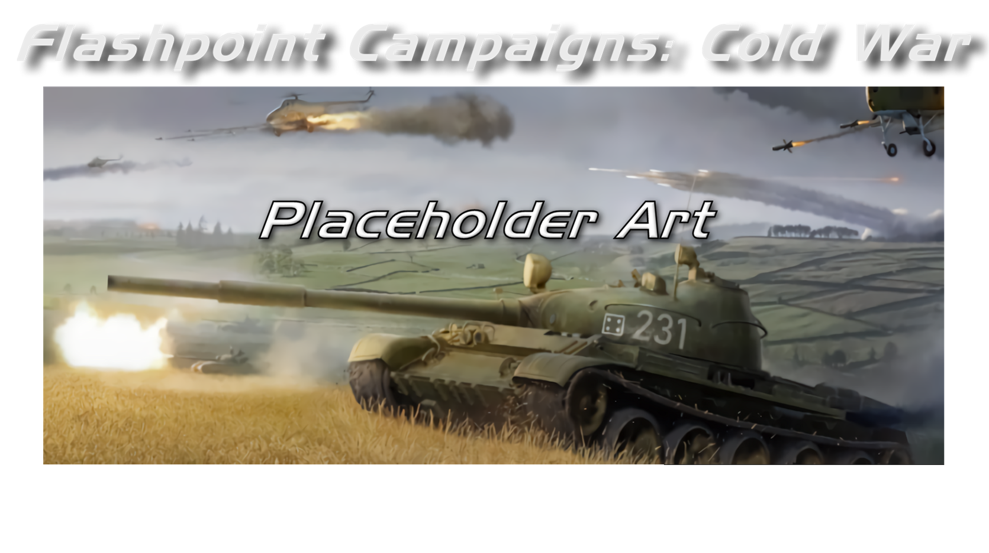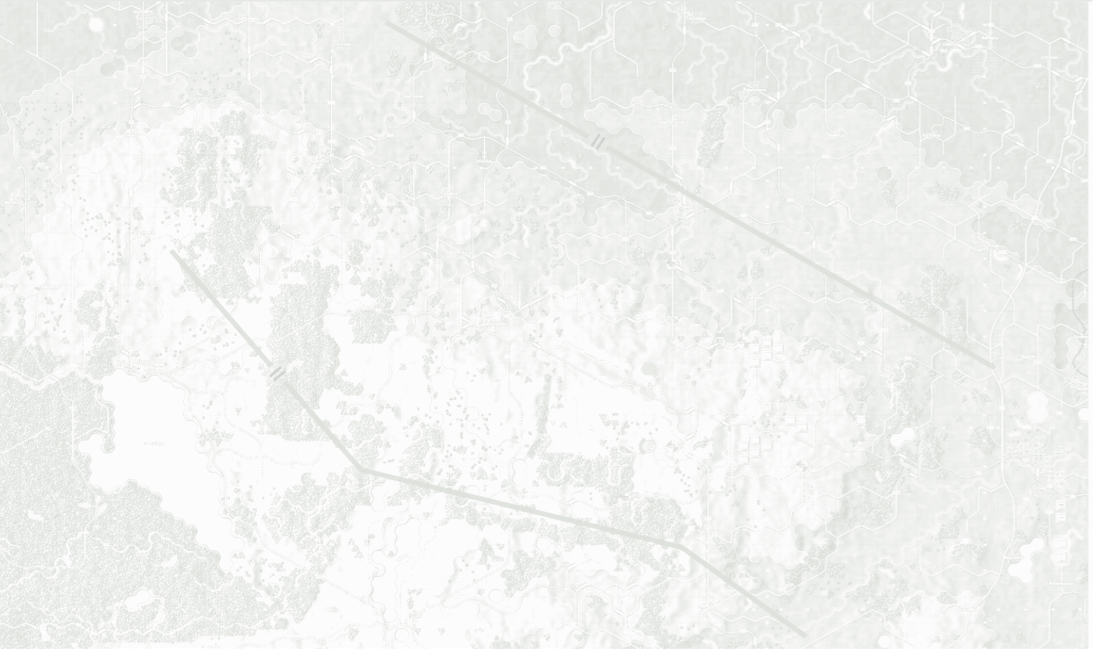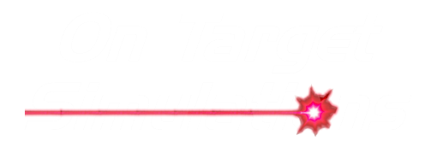

Data Structures and Editing

Field Manual FCCW-09/R1

**© 2025 On Target Simulations (OTS), LTD. All Rights Reserved. The images used and OTS Logo are property of On Target Simulations, LTD. All other marks and trademarks are the property of their respective owners.**

Table of Contents

1 Introduction 8

1.1 What's in This Document 8

1.2 Manuals 9

1.2.1 The Field Manuals (FM) 9

1.2.2 What’s New 9

1.2.3 FPC Hotkeys 9

1.2.4 Flashpoint Campaigns: Cold War FAQ 9

1.3 Gender Pronouns and Inclusion 9

2 Location of Data Files 10

2.1 Tools to use on the Data Files 10

3 Data File Structure Overview 10

3.1 National Tab 10

3.2 Command Tab 11

3.3 Formations Tab 11

3.4 Units Tab 11

3.5 Systems Tab 11

3.6 Munitions Types Tab 11

3.7 Surnames Tab 11

3.8 Credits Tab 12

3.9 Notice Tab 12

4 Platform Types 12

4.1 Air Platforms 12

4.2 Ground Troop Platforms 12

4.3 Land Platforms 13

4.4 Land Based Logistical Sites 14

4.5 Weapon Locating Radar (Off-Map) 14

4.6 Additional Sub-Unit Types 14

5 Platform Characteristics 14

5.1 Unit Level Characteristics 14

5.2 Systems/Munitions Level Characteristics 23

5.3 Munitions Only Level Characteristics 25

6 Weapon/System Types 26

6.1 Ballistic Class 26

6.2 Energy Class 26

6.3 Guided Class 26

6.4 NBC Class 26

7 Munition Types 27

8 Weapon List Codes (New-Provisional) 27

9 Task Force Type Filters 28

10 Formation Roles 28

11 Battle Planner Template (BPT) Codes 29

11.1 Independent Air Defense 29

11.2 Air Operations 29

11.3 Independent Artillery Operations 30

11.4 Ground Maneuver/Engineering 30

11.5 Helo Operations 30

11.6 NBC/SSM Operations 30

11.7 Generic (Catch All) 30

12 Mobility Types 31

13 Getting Started with Data Editing 31

13.1 Deciding What You Want to Make 31

13.2 New or Derived Content 31

13.3 Gathering Source Information 32

13.4 Safeguarding Sensitive or Classified Data 32

13.5 Third Party Tools and Other Assets 32

13.6 Working with User Feedback 32

14 Editing the Data 32

14.1 The Hell of Spreadsheet Editing 32

14.2 Save Early, Save Often, and Have Backups 32

14.3 Words of Wisdom… 32

15 National Defaults 33

15.1 Time Frame Start/End 33

15.2 Hardware Quality Values 33

15.2.1 Electronics 33

15.2.2 Countermeasures 33

15.2.3 Equipment 33

15.3 Default Military Unit Values 33

15.3.1 Training 34

15.3.2 Morale 34

15.3.3 Tactical Initiative 34

15.3.4 Acceptable Losses 34

15.4 Artillery Values 34

15.4.1 Delay: On Call Fire 34

15.4.2 Delay: Between Fire Mission 34

15.4.3 % CB Detection (Legacy) 34

15.4.4 Max FSCC Age-Static Target 34

15.4.5 Max FSCC Age-Moving Target 35

15.4.6 FSCC-Min Tubes per Mission 35

15.5 Engineering Values 35

15.5.1 Minor River Bridging Time 35

15.5.2 Stream Crossing Time 35

15.5.3 Swimming Prep Time 35

15.5.4 Blow Bridge 35

15.5.5 Clear Mines 35

15.5.6 Clear Obstacle 35

15.5.7 Clear Improved Position (IP) 35

15.6 Game Defaults 35

15.6.1 Unit Counter Background Image 35

15.6.2 Subunit Stacking Limit 36

15.6.3 Nationality 36

15.6.4 Insignia 36

15.6.5 Force Name 36

15.6.6 Default Side 36

15.6.7 Equipment Cost Factor 36

16 Command 37

16.1 HQ Level 37

16.2 Size Symbol 37

16.3 Rank(s) 37

16.4 Rank Abr 37

16.5 Radii (m) 37

16.6 Delay (Min) 37

16.7 US Rank Name 37

16.8 US Rank Abr 37

16.9 NATO Code 37

17 Formations 38

17.1 Description (Format Use) 38

17.1.1 Major Formation Identifiers 38

17.1.2 End Major Group Fields 38

17.1.3 Type Formation Identifiers 38

17.1.4 Minor Group Separators 39

17.1.5 Blank Lines 39

17.2 Description (Information Use) 39

17.3 Code 39

17.3.1 Indented Node Code 39

17.4 Tag 41

17.5 Composition 41

17.6 Role 41

17.7 Unit Size 41

17.8 Is HQ Of 41

17.9 BPT Default 42

17.10 Task Force Type 42

17.11 Formation Format Best Practices 42

18 Description (IUnits 42

18.1 SUTag 42

18.2 Name 42

18.3 NATO Designation 42

18.4 PICID 42

18.5 NATOPIC 43

18.6 Description 43

18.7 SU Type 43

18.8 CompID 43

18.9 First Year Avail 43

18.10 Last Year Avail 43

18.11 Crew 43

18.12 Mobility 43

18.13 Speed 43

18.14 Transport (Organic) 43

18.15 Size 44

18.16 Mass 44

18.17 IntTrp 44

18.18 IntWt 44

18.19 ExtTrp 44

18.20 ExtWt 44

18.21 FC/RF 44

18.22 Stab 44

18.23 The Characteristics Lists 45

18.23.1 Abilities List 45

18.23.2 Defenses List 45

18.23.3 Equipment List 45

18.24 Integrated Weapons List 45

18.24.1 System with Single Ammo Allocation 45

18.24.2 System with Munitions 45

18.25 PF (Protection Factor) 46

18.25.1 PF for Soft Units 46

18.25.2 PF for Air Units 46

18.25.3 PF for Ground Vehicle Units 46

19 Defining Armor Value and Specials 46

19.1 Hull to Turret Ratio (HTR) 46

19.2 Advanced Composite Armour (ACA) 47

19.3 Explosive Reactive Armour (ERA) 47

19.4 HEAT Resistant Armour (HRA) 48

19.5 Skirt Armour (SKT) 49

19.6 Values for Side and Top/Rear 49

20 Air Unit Size and PF Rating Calculator 49

20.1 Adding More Data 49

21 Systems 50

21.1 WEAPTAG 50

21.2 Name 50

21.3 NATO Designation 50

21.4 Description 51

21.5 Type 51

21.6 Role 51

21.7 Accuracy 51

21.7.1 Guided/Smart Weapons 51

21.7.2 Non-Guided Weapons 52

21.8 Range 52

21.9 Effective Range 52

21.10 Min Range 52

21.11 SA Value 52

21.11.1 SA Value for Artillery Guns 53

21.11.2 SA Value for Mortars 53

21.11.3 SA Value for Rockets 53

21.11.4 SA Value for Small Arms 54

21.11.5 SA Value for Tank HE Rounds 55

21.12 AP Pen 55

21.13 HEAT Pen 55

21.14 Weapon Lists 55

21.14.1 Capabilities List 56

21.14.2 Defenses List 56

21.14.3 Guidance List 56

21.15 Sound Effect 56

22 Weapon Munition Types 56

22.1 The Munition Types Tab 57

22.2 Columns Based on Systems Values 57

22.3 Columns for the Munition Types 57

22.3.1 AmmoTypeID 57

22.3.2 WpnID 57

22.3.3 Name 58

22.3.4 Description 58

22.3.5 Type 58

22.4 Setting Up Munition Types 58

22.4.1 Munition Type Entry 59

23 Surnames 59

24 Credits 59

25 Notice 59

26 Data Folder Setup 59

27 Using the Data Validation Tool 60

27.1 Make a Data Check File 60

27.1.1 Steps to Follow 60

27.2 How to use this Tool 61

27.3 Updating the Main Data File 63

27.4 Additional Tool Features 64

27.4.1 Worksheet Header Check 64

27.4.2 Data Elements Check 65

27.4.3 Formation Tab Checks 65

27.4.4 Units Tab Checks 65

27.4.5 Unused Units Check 65

28 File XLS Import/Export Editing 66

28.1 Exporting Scenario Data 66

28.2 Editing Scenario Data 68

28.3 Best Use Cases for the Tool 71

28.4 Importing Scenario Data 71

28.5 Limitations/Uses of this Tool 72

29 Future Updates 73

30 Flashpoint Campaigns Credits 74

30.1 On Target Simulations 74

30.2 On Target Simulations Content Team 74

30.3 Cold War Beta Testers 74

30.4 Matrix Production Support 74

31 OTS on the Web 75

# Introduction

Welcome to FLASHPOINT CAMPAIGNS: COLD WAR

This is a grand tactical combat simulation on the Cold War battlefield. As the force Commander, you will plan and then issue orders and Standard Operating Procedures to your battalion, brigade, or regimental forces, shaping the fight by maneuver and your intent. Your forces will engage the enemy on rendered real-world map locations. Each hex is 500m of militarily significant terrain. Each battle can last 4 to 24 hours of in-game time. Your troops will meet their foes any time of day and in any environment.

The game engine is based on asynchronous WEGO turns. This means you will issue orders and then watch a variable amount of time unfold on the battlefield. Then, issue or adjust orders to react to what has happened as you execute your battle plan.

***Flashpoint Campaigns: Cold War*** is a deep simulation of combat operations where your forces are arranged in maneuver units of companies, platoons, and sections of tanks, infantry fighting vehicles, infantry squads and teams, recon forces, engineers, air-defense and anti-tank systems, helicopters and more. As the Commander, you must use available off-map assets like long-range artillery, rockets, or airstrikes.

Your efforts in this complex battlespace will be constantly challenged by modeled features like Electronic Warfare, Air Superiority, Realistic Weather, Line of Sight and Fire, Terrain and Elevation, Smoke and Mines, and Human Factors like training, morale, and readiness. All these elements must be considered if you are to be victorious on the battlefield.

The game is packed with information dialogs, map overlays, and range rings to aid you as Commander, master the situation, and understand your force’s capabilities.

***Flashpoint Campaigns: Cold War*** is a data-rich simulation where each nation has information on National Characteristics, Command Parameters, and Orders of Battle. Data Tables are packed with era-specific equipment and troops. Weapon Systems of the time, such as guns, missiles, precision munitions, small arms, and much more, are comprehensively modeled.

As a toolkit, you can create your own scenarios and campaigns. You can also dive deeper and create or modify game data, artwork, and sound effects as you see fit. All these modding capabilities are supported by detailed documentation.

## What's in This Document

This document provides the information necessary to edit, create, and validate the National Data Files used in the game. There is a lot of information in this document and users are urged to start small and work up to new data files.

**NOTE:** All data provided by On Target Simulations LTD is gathered from unclassified, open sources and best-guess estimations from our team. ***Do not*** use information or data from sensitive or classified military sources in your mods.

**NOTE:** Areas of interest or buttons on form pictures are outlined in red.

**NOTE:** Some images in this manual are from other game versions. While your maps and units may differ, all the information and how it is used and displayed will match the information in this manual.

## Manuals

We have chosen to go with many living manuals to cover game interface/play, learning the game, basic tactics, Content Creation, and Game Modding for the Cold War game engine. We also have guides that cover that area of operations. The affected manuals and guides will be updated as the game is updated, and PDFs of these changes will be included with the new patches.

### The Field Manuals (FM)

These are the core manuals on how to play, create content for, and modify data for the Cold War game engine. Before jumping into Content Creation, we strongly recommend you review the first three manuals, **Game Operations**, **Battlefield Primer**, and **Tutorial Operations,** if you are new to this type of game and warfare. Returning Flashpoint Campaigns players should review **Game Operations** to get details on new features, as there are many.

These documents are found in the Documents\FMs folder.

* FM01: Game Operations – Detailed information on the game, its interface, and how to use it
* FM02: Battlefield Primer – Fighting in the Cold War
* FM03: Tutorial Operations – How to learn and play the game
* FM04: Scenario Design – How to make or edit scenarios
* FM05: Battle Planning – How to create or edit battle plans. Battle Planning is a unique topic of Scenario Design.
* FM06: Campaign Design –How to make or edit campaigns
* FM07: Map Construction –How to make simple maps for the game
* FM08: Game Engine Modifications - How to Mod elements of the game engine
* FM09: Data Structures and Editing– ***This Manual*** – How to edit or build data sets
* FM10: Weather Setup – How to add in weather from other locales

### What’s New

The What’s New PDFs summarize any changes and fixes when updates are released.

These can be found in the Documents\WhatsNew folder.

### FPC Hotkeys

This PDF document lists all the unique game key presses for Function keys and all hotkey definitions. Due to the large number of functions in the game, rebinding is not possible.

This document is in \Documents folder.

### Flashpoint Campaigns: Cold War FAQ

To stave off forum-clogging threads on various topics we either don't control or can't support, we created this FAQ document with the answers to those specific topics.

Please review the FAQ for answers to several game topics related to the game but not on how to play the game.

This document is in the \Documents folder.

## Gender Pronouns and Inclusion

We understand that users of all genders will play our simulation. We try to keep language in the game and manuals gender-neutral, when possible, but sometimes use the pronoun “he” to refer to the user. This is merely to streamline the writing, not to exclude anyone or note a specific gender.

The On Target Simulations team supports the inclusion of all people in the field of wargaming.

# Location of Data Files

All the data files and data tool files are in the games installation location in the ...Modules/Common/Data folder. In that Data folder there are several national folders and in each there are one or more Excel spreadsheets that contain the data of interest for this manual.

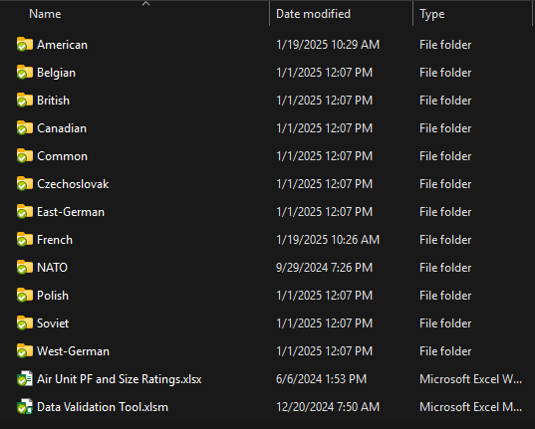

## Tools to use on the Data Files

To edit the data files, you will need a spreadsheet editing capable program like Excel for Office or equivalent. The files are not protected, but care should be taken to follow the instructions provided in this manual to avoid game crashes.

# Data File Structure Overview

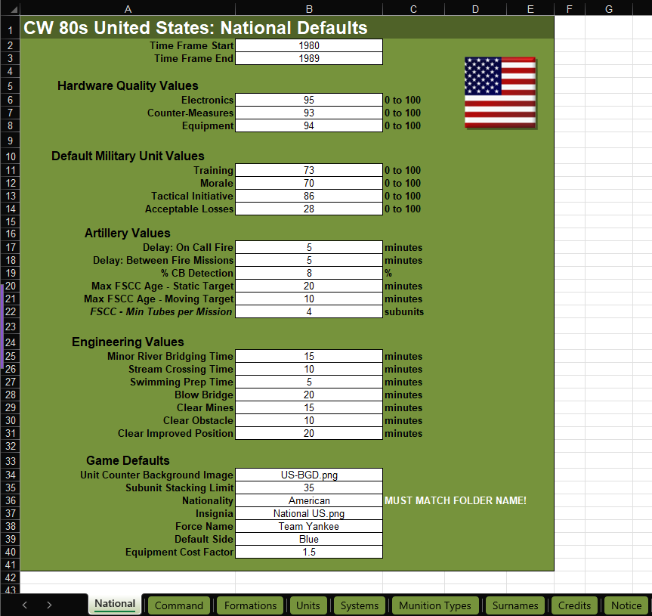We will look at each of the tabs found in a National Data File used in this version of the Flashpoint Campaigns game engine. Each entry for a given tab will be noted as to its functionality. Data files have nine tabs. Each has a function for the game. Data files are created and modified in Excel or compatible programs.

## National Tab

The information on this tab relates to values based on the country in question for each of the capabilities listed.

## Command Tab

This table contains all the factors for in-game leaders and their command parameters. The table covers the command values from Corps down to Squad and has values for Size Symbol, Rank, Rank Abbreviation, Command Radius, and Command Delay (within the local radius). There are reference columns for the US Rank Equivalent, US Rank Abbreviation and NATO Code for each command level. There is an option in the game that allows the selection of native national ranks or to us the US equivalents in game.

## Formations Tab

The formation tab contains information for defining the numerous orders of battle formations for a nation’s forces. Also included are air formations, strategic assets, engineering assets, and low use units. These formations are used in the game’s scenario editor to create formations and specify the correct equipment types in those formations.

## Units Tab

This tab contains the data related to each type of unit used by a nation. This includes troops and teams, land vehcles, and air platforms. The data notes the properties and capabilites of the unit via text, numbers, and characteristic codes.

## Systems Tab

This tab contains the data related to each type of system or weapon used by a nation on the units listed in the Units tab. This includes systems like tank guns, ATGMs, mortars, and other systems. The data notes the properties and capabilites of the system via text, numbers, and characteristic codes.

## Munitions Types Tab

This tab provides data for the various types of munitions fired by certain weapon systems found in the game. These types of weapons will have the ability to engage different targets or perform various missions.

## Surnames Tab

One of the tabs added to the National Data File is the Surnames tab. Surnames are used to add a name to the various leaders found in the game. The 200 names are country specific as well.

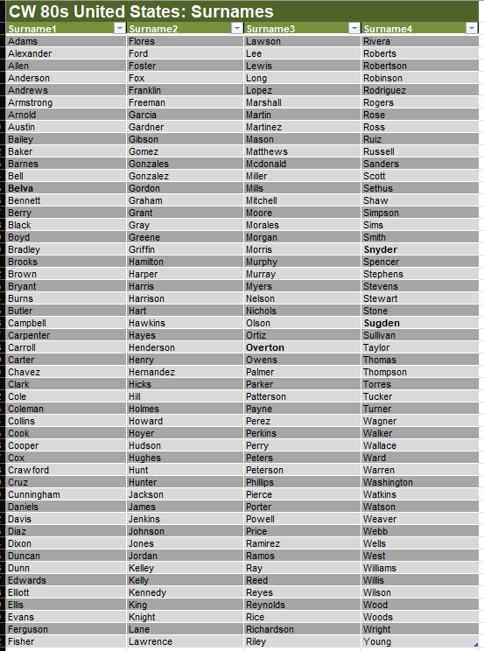

## Credits Tab

Other than the naming convention for the top cell and some color tweaks the new and RS Credit’s tab contain the same information. 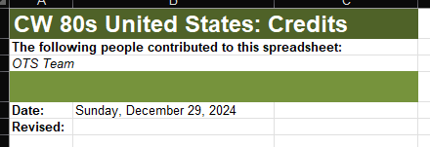

## Notice Tab

This tab is used to provide the following information about the data file. The information states:

* Game Engine
* Nation/User of Data File
* Creator of Data File
* 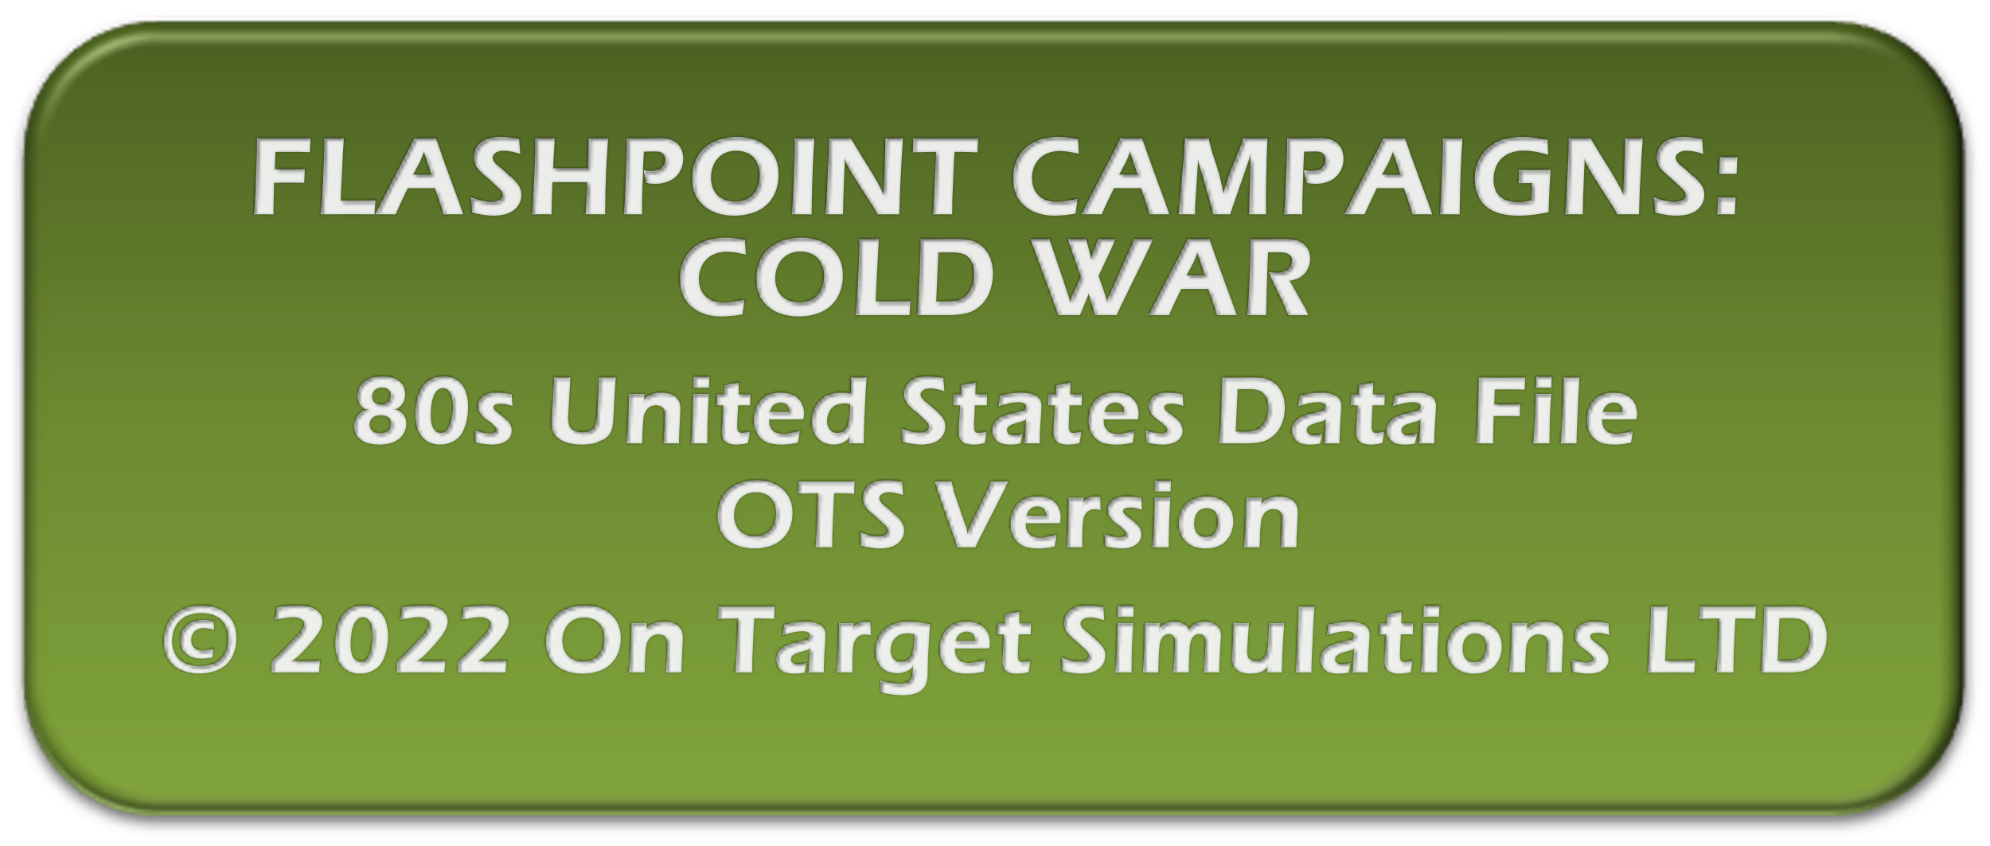Copyright reflects the full On Target Simulations LTD name and is dated for the year the work was done.

# Platform Types

This section will cover the basic types of unit platforms found in the game. Subunit Types are predefined and used in the game code for various functions.

**WARNING:** Users **cannot** add their own types directly.

## Air Platforms

These 19 platforms cover everything from Aircraft, Airships, and Helicopters to Large Ballistic Missiles.

|  |  |  |
| --- | --- | --- |
| **Sub-Unit Type** | **Class (Bit Use)** | **Description** |
| AIRAT | AIR | A Jet or Prop CAS Aircraft (not dive) |
| AIRDB | AIR | A Jet or Prop Dive Bomber |
| AIRGL | AIR | A Glider/Unpowered Aircraft |
| AIRGS | AIR | A Prop or Jet Gunship |
| AIRLB | AIR | A Jet or Prop Level Bomber |
| AIRRK | AIR | Rocket Powered Aircraft |
| AIRSC | AIR | A Jet or Prop Scout |
| AIRSD | AIR | A Jet or Prop SEAD Aircraft |
| AIRUT | AIR | A Jet or Prop Transport |
| DRNAIR | DRONE | Unmanned Air Unit |
| HELOAT | HELO | An Attack Helicopter |
| HELOSC | HELO | A Scout Helicopter |
| HELOUT | HELO | A Utility Helicopter |
| SSMSL | SSM | Surface to Surface Missile |

## Ground Troop Platforms

These platform types cover all leg infantry units and crew served towed weapon systems.

|  |  |  |
| --- | --- | --- |
| **Sub-Unit Type** | **Class (Bit Use)** | **Description** |
| FLAK | AD | Towed Flak |
| ARTY | ARTY | Towed Artillery |
| MTRWS | ARTY | Towed Mortar Weapon System |
| RKTWS | ARTY | Towed Multi-Rocket Weapon System |
| ATWS | AT | Towed Anti-Tank Weapon System |
| DRNGTP | DRONE | Drone Ground Troop |
| ENGR | ENGR | Engineering Unit |
| INFAC | INF | A Forward Air Controller Unit |
| INFAG | INF | A RPG Infantry Unit |
| INFAM | INF | An ATGM Infantry Unit |
| INFAT | INF | An Anti-Tank Infantry Unit |
| INFBK | INF | A Bike Infantry Unit |
| INFCV | INF | A Cavalry Unit |
| INFFO | INF | A Forward Observer Unit |
| INFGL | INF | A Grenade Launcher Unit |
| INFHQ | INF | A Headquarters Unit |
| INFLG | INF | A Leg Infantry Unit |
| INFMC | INF | A Motorcycle Infantry Unit |
| INFME | INF | A Mechanized Infantry Unit |
| INFMG | INF | A Machine Gun Unit |
| INFMO | INF | A Motorized Infantry Unit |
| INFMP | INF | A Military Police Unit |
| INFMR | INF | A Mortar Infantry Unit |
| INFMT | INF | A Mountain Infantry Unit |
| INFNV | INF | A Naval Infantry Unit |
| INFSC | INF | A Scout Unit |
| INFSM | INF | A SAM Infantry Unit |

## Land Platforms

These platform types cover all land-based vehicle systems.

|  |  |  |
| --- | --- | --- |
| **Sub-Unit Type** | **Class (Bit Use)** | **Description** |
| ACAR | ACAR | An Armored Car |
| ABAD | AD | Airborne Air Defense Vehicle |
| MOBSAM | AD | A Mobile SAM System |
| SAMWS | AD | Fixed SAM Weapon System |
| SPFLAK | AD | Self-Propelled Flak |
| SPSAM | AD | Self-Propelled SAM |
| ABVT | APC | Airborne Vehicle Tracked |
| ABVW | APC | Airborne Vehicle Wheeled |
| APCT | APC | A Tracked APC |
| APCW | APC | A Wheeled APC |
| ABARTY | ARTY | Airborne Artillery Gun (Air Droppable) |
| SPARTY | ARTY | Self-Propelled Artillery |
| SPMTR | ARTY | Self-Propelled Mortar |
| ABAT | AT | Airborne Anti-Tank Vehicle |
| SPAT | AT | Self-Propelled Anti-Tank |
| ABCV | COMV | Command Vehicle |
| COMV | COMV | Command Vehicle |
| ABCS | CSV | Airborne Combat Support Vehicle |
| CMSV | CSV | Combat Support Vehicle |
| DRNLND | DRONE | Drone Vehicle |
| ENGV | ENGV | Engineering Vehicle |
| IFVT | IFV | Infantry Fighting Vehicle Tracked |
| IFVW | IFV | Infantry Fighting Vehicle Wheeled |
| SNSR | SENSOR | A Fixed Sensor Site |
| SPSNR | SENSOR | Self-Propelled Sensor |
| OBSV | RECON | A Dedicated Spotting Vehicle |
| RECCE | RECON | A Recon Unit |
| **Sub-Unit Type** | **Class (Bit Use)** | **Description** |
| SPRKT | RKT | Self-Propelled Rocket |
| ABTK | TANK | Airborne Tank (Air Droppable) |
| TANK | TANK | Tank (Light to MBT) |
| TANKAM | TANK | Amphibian Tank |
| TANKFL | TANK | Flame Tank |
| TANKSG | TANK | Self-Propelled Gun |
| UTYA | UTY | Artillery Towing Vehicle |
| UTYO | UTY | Utility Transport Organic-Wagon |
| UTYT | UTY | Utility Transport Tracked |
| UTYW | UTY | Utility Transport Wheeled |

## Land Based Logistical Sites

There is currently one Land-Based Logistical Site. Others are being looked at for future additions.

|  |  |  |
| --- | --- | --- |
| **Sub-Unit Type** | **Class (Bit Use)** | **Description** |
| FARP | LOG | FARP for Helicopters/VTOLS (Fixed) |

## Weapon Locating Radar (Off-Map)

|  |  |  |
| --- | --- | --- |
| **Sub-Unit Type** | **Class (Bit Use)** | **Description** |
| WLR | SENSOR | Fixed Weapon Locating Radar |
| SPWLR | SENSOR | Mobile Weapon Locating Radar |

## Additional Sub-Unit Types

As we expand the game, more Sub-Unit types will be added to the lists, and we will update the documentation.

**WARNING:** You cannot add or alter SubUnit types in the data files. Do so will cause scenarios with that modified data will crash the game.

# Platform Characteristics

Characteristics define certain special abilities or capabilities for Units, Systems/Munitions, and Munitions Only in the game. Characteristics are broken down into Types and then further separated into Sub-Types.

## Unit Level Characteristics

The following classes of characteristics can be found in the three lists (Abilities, Defenses, and Equipment) found on the Units tab of a national datasheet.

* **ab-en: Abilities-Engineering -** For engineering platforms, giving them abilities, such as bridging, mine laying, demolition, etc.
  + EGBL: Bridging (Engr) - Long Span. Pontoon type unit, longer to assemble.
  + EGBS: Bridging (Engr) - Short Span. AVLB type units, 10-20 minutes to drop/pickup.
  + EGMR: Mine Removal (Engr). Units can remove mines.
  + EGDM: Demolitions (Engr). Blowing up bridges, obstacles, hardened shelters, etc.
  + EGIP: Improved Positions (Engr). Trenches, improved positions, ramped locations, fox holes, etc. Extra protection to units.
  + EGML: Mine Laying (Engr). Units can lay mines.
  + EGPO: Place/Create Obstacle (Engr). Units can build roadblocks, hedgehogs, dragons teeth, trenches, etc., impeding movement.
* **ab-gn: Abilities-General -** For any unit. Things like Mast Mounted Sights, Forward Observer, Unmanned platform, and so on. There is no common theme for this family.
  + ADP: Flak / Air Defense Platform. The unit is designed to engage air targets.
  + AVS: Avionics. Flavor text for air units stating electronic instrumentation.
  + ECR: Extended Command Range. Ability to work at longer ranges from local HQ, recon units mainly.
  + ICR: Infinite Command Range. Unit can operate at any distance from local HQ without penalty, spec-ops/LRPs.
  + RDS: Command and Control Radio Systems. Sources of radio signal traffic, too much activity can generate a detectable source point.
  + IDY: Inflatable Decoy. An inflatable or static mockup of a decoy platform.
  + MMS: Mast Mounted Sights. Sensors/designators in mast, unit harder to spot/shoot, etc.
  + MMW: Mast Mounted Weapon System. Unit can fire weapons while crew/vehicle remain in full cover.
  + PSS: Periscope Sighted System. Unit can be turret down and search/track targets, harder to spot in cover.
  + UPA: Unmanned Platform - Autonomous. No pilot/crew on the platform, AI operated.
  + UPP: Unmanned Platform - Programmed. No pilot/crew on the platform follows pre-programmed route.
  + UPR: Unmanned Platform - Remote. No pilot/crew on the platform, remote operated.
  + UPS: Unmanned Platform - Semi-Autonomous. No pilot/crew on the platform, remote operated or AI, can switch types.
  + TLM: Tube Launched Missile (ATGM from the main gun barrel). Unit can fire an ATGM in place of a cannon shot-Must count as SFR shot.
  + RCP: Recon Platform. Unit has better spotting, reduced spottable, and stealthier movement.
  + WAFP: Wide Area Fire Platform. Saturate a target area with fire, center hex and surrounding ring of hexes.
  + FARP: Forward Arming and Resupply Point. In-game, but not fully coded as a logistical type. Allow Helos on Ships.
* **ab-tr: Abilities-Transport -** This family encompasses abilities not only related to transport, but movement as well. Things like Tow Capable (towing a gun or trailer), Very High Altitude, and Quick Scoot Platform.
  + ABLD: Landed Altitude Band. Air Unit is landed on the ground.
  + ABNE: Nap of Earth Altitude Band. Nap of Earth flying/ground masking for helos and drones.
  + ABEL: Extremely Low Altitude Band. Dash flying for helos and drones, maybe some aircraft.
  + ABVL: Very Low Altitude Band. Very Low flight for Close Air Support (CAS) aircraft.
  + ABLW: Low Altitude Band. Low flight for CAS aircraft.
  + ABMD: Medium Altitude Band. Medium flight for Bombers and SEAD aircraft.
  + ABHG: High Altitude Band. High level flight profile for Bombers, SEAD, and Recon aircraft.
  + ABVH: Very High Altitude Band. Very High flight for Recon aircraft.
  + ABEH: Extremely High Altitude Band. Extremely High flight for Recon/Hypersonic aircraft.
  + ABSP: Space/Orbital Altitude Band. Platforms operating in space or suborbital.
  + AMP: Amphibious Unit. Units can traverse water obstacles at a greatly reduced speed.
  + MNL: Movement Not Limited. Units (motorcycles) are not slowed in any ground terrain.
  + NNF: Nimble NOE Flight. Helo capable of very low (close NOE), bonus defense/reduced spotting.
  + TWL: Towed Weapon Leg. Weapon systems can be moved by leg troop/team.
  + TWS: Towed Weapon System. Weapon systems can only be moved by vehicle.
  + HLP: Heavy Lift Platform. Units can carry or move large, heavy items like field guns or light vehicles or troops.
  + SLP: Sling Load Platform. "Towing" for Helos with cargo hooked up under the helicopter.
  + TCP: Tow Capable Platform. Can tow/move TWS (Towed Weapon Systems).
  + AWL: All Weather - Limited. Air/Helo - Operate in bad weather with reduced spotting accuracy.
  + AWN: All Weather - Normal. Air/Helo - Operate in bad weather without penalties.
  + NOL: Night Ops Limited. Operate at night with reduced spotting accuracy.
  + NON: Night Ops Normal. Operate at night as day for spotting and movement.
* **ab-lg: Abilities-Logistical -** This family encompasses abilities related to various static logistical facilities to be used in the game. Currently, only FARP is active.
  + FARP: Forward Arming and Resupply Point. VPs and data for FARPs - Helo, Drone and VTOL Aircraft refuel and rearming.
* **df-ab: Defense-Abilities -** This is rather a catch-all for defense related characteristics that don’t fit well into either countermeasures or Protection Factor enhancers. You will find things like Body Armor, Mine Resistant Design, and Hull to Turret Ratio here.
  + HTR1: Hull to Turret Ratio, Type 1. Ratio is <.60 for Hull PF / Turret PF rating, -50% to PF adjustment for hull hits.
  + HTR2: Hull to Turret Ratio, Type 2. Ratio is .60 to .75 for Hull PF / Turret PF rating, -30% to PF adjustment for hull hits.
  + HTR3: Hull to Turret Ratio, Type 3. Ratio is .75 to .90 for Hull PF / Turret PF rating, -15% to PF adjustment for hull hits.
  + HTR4: Hull to Turret Ratio, Type 4. Ratio is .90 to 1.10 for Hull PF / Turret PF rating, no adjustment for hull hits [0.95].
  + HTR4A: Hull to Turret Ratio, Type 4A. Ratio is .90 to 1.10 for Hull PF / Turret PF rating, no adjustment for hull hits [1.0].
  + HTR5: Hull to Turret Ratio, Type 5. Ratio is 1.10 to 1.25 for Hull PF / Turret PF rating, +15% to PF adjustment for hull hits.
  + HTR6: Hull to Turret Ratio, Type 6. Ratio is 1.25 to 1.40 for Hull PF / Turret PF rating, +30% to PF adjustment for hull hits.
  + HTR7: Hull to Turret Ratio, Type 7. Ratio is >1.40 for Hull PF / Turret PF rating, +50% to PF adjustment for hull hits.
  + NBCB: NBC Basic/MOPP. MOPP.
  + NBCL: NBC Limited Protection. Centralized filtration system.
  + NBCP: NBC Protected. Over pressure/liner.
* **df-cm: Defense-Countermeasures -** These characteristics generally affect the Ph of an attacker. Here we’ve put legacy countermeasures such as smoke, chaff, and flares. We also include ECCM type systems.
  + ADCR1: Air Defense Counter Measure Resistance. x = 1(low) to 5(very good).
  + ADCR2: Air Defense Counter Measure Resistance. x = 1(low) to 5(very good).
  + ADCR3: Air Defense Counter Measure Resistance. x = 1(low) to 5(very good).
  + ADCR4: Air Defense Counter Measure Resistance. x = 1(low) to 5(very good).
  + ADCR5: Air Defense Counter Measure Resistance. x = 1(low) to 5(very good).
  + DCM: Defensive Counter Measures (Chaff and Flares). Basic anti-missile countermeasures, tech level delta's for effectiveness.
  + ECM: Electronic Counter Measures. jamming radar uses tech levels for effectiveness.
  + SDMS: Smoke Discharger - Multi-Spectral. blocks Line of Sight (LoS) of visual, TI, and Radar systems.
  + SDN: Smoke Discharger-Normal. Smoke blocks visual line of sight.
  + SDT: Smoke Discharger - Thermally Blocking. blocks LoS of both visual and TI systems.
  + TIJ: Thermal-Optical Jamming System. System used to jam EO/Laser based weapons (jams PGL/PGO). Like the Soviet Shtora-1 system.
  + AFC: Advanced Field Camouflage. SOF/Sniper/Long Range Recon (LLR) if not moving very hard to spot in hex, reduced visual spot on move.
  + IRSUP: IR Suppression System. Platform is slightly harder to detect with Thermal systems and IR weapon seekers.
  + LOP: Low Observable Platform. Difficult to detect by radar and IR systems.
  + MSAC: Multi-Spectral Applied Camouflage. Greatly reduces IR, Thermal, Radar Signature, small reduction to optical.
  + STP: Stealth Platform. Very hard to detect by radar and IR systems.
  + USC: Unit Stealth Capability. Ground troops with added ability to mask signature and hide from sensors.
* **df-pr: Defense-Protection -** These mainly serve to attenuate anti-armor attack strength. In this family, you will find Explosive Reactive Armor, Advanced Composite Armor, Active Protection Systems. Skirt armor, and more.
  + ACAH1: Advanced Composite Armor (Effectiveness 1). <1.25 ratio, Hull, Aspect Coded (F/S/R/T).
  + ACAH2: Advanced Composite Armor (Effectiveness 2). <1.25 : 1.5 ratio, Hull, Aspect Coded (F/S/R/T).
  + ACAH3: Advanced Composite Armor (Effectiveness 3). <1.5 : 1.75 ratio, Hull, Aspect Coded (F/S/R/T).
  + ACAH4: Advanced Composite Armor (Effectiveness 4). <1.75 : 2.0 ratio, Hull, Aspect Coded (F/S/R/T).
  + ACAH5: Advanced Composite Armor (Effectiveness 5). >2.0 ratio Hull, Aspect Coded (F/S/R/T).
  + ACAH1FSRT: Advanced Composite Armor (Effectiveness 1), Hull; Front, Side, Rear, Top. <1.25 ratio, Hull, Aspect Coded (F/S/R/T).
  + ACAH2FSRT: Advanced Composite Armor (Effectiveness 2), Hull; Front, Side, Rear, Top. 1.25 :<= 1.5 ratio, Hull, Aspect Coded (F/S/R/T).
  + ACAH3FSRT: Advanced Composite Armor (Effectiveness 3), Hull; Front, Side, Rear, Top. 1.5 : <=1.75 ratio, Hull, Aspect Coded (F/S/R/T).
  + ACAH4FSRT: Advanced Composite Armor (Effectiveness 4), Hull; Front, Side, Rear, Top. 1.75 : <=2.0 ratio, Hull, Aspect Coded (F/S/R/T).
  + ACAH5FSRT: Advanced Composite Armor (Effectiveness 5), Hull; Front, Side, Rear, Top. >=2.0 ratio, Hull, Aspect Coded (F/S/R/T).
  + ACAH1FSR: Advanced Composite Armor (Effectiveness 1), Hull; Front, Side, Rear. <1.25 ratio, Hull, Aspect Coded (F/S/R).
  + ACAH2FSR: Advanced Composite Armor (Effectiveness 2), Hull; Front, Side, Rear. 1.25 :<= 1.5 ratio, Hull, Aspect Coded (F/S/R).
  + ACAH3FSR: Advanced Composite Armor (Effectiveness 3), Hull; Front, Side, Rear. 1.5 : <=1.75 ratio, Hull, Aspect Coded (F/S/R).
  + ACAH4FSR: Advanced Composite Armor (Effectiveness 4), Hull; Front, Side, Rear. 1.75 : <=2.0 ratio, Hull, Aspect Coded (F/S/R).
  + ACAH5FSR: Advanced Composite Armor (Effectiveness 5), Hull; Front, Side, Rear. >=2.0 ratio, Hull, Aspect Coded (F/S/R).
  + ACAT1: Advanced Composite Armor (Effectiveness 1). <1.25 ratio, Turret, Aspect Coded (F/S/R/T).
  + ACAT2: Advanced Composite Armor (Effectiveness 2). <1.25 : 1.5 ratio, Turret, Aspect Coded (F/S/R/T).
  + ACAT3: Advanced Composite Armor (Effectiveness 3). <1.5 : 1.75 ratio, Turret, Aspect Coded (F/S/R/T).
  + ACAT4: Advanced Composite Armor (Effectiveness 4). <1.75 : 2.0 ratio, Turret, Aspect Coded (F/S/R/T).
  + ACAT5: Advanced Composite Armor (Effectiveness 5). >2.0 ratio Turret, Aspect Coded (F/S/R/T).
  + ACAT1FSRT: Advanced Composite Armor (Effectiveness 1), Turret; Front, Side, Rear, Top. <1.25 ratio, Turret, Aspect Coded (F/S/R/T).
  + ACAT2FSRT: Advanced Composite Armor (Effectiveness 2), Turret; Front, Side, Rear, Top. 1.25 : <=1.5 ratio, Turret, Aspect Coded (F/S/R/T).
  + ACAT3FSRT: Advanced Composite Armor (Effectiveness 3), Turret; Front, Side, Rear, Top. 1.5 : <=1.75 ratio, Turret, Aspect Coded (F/S/R/T).
  + ACAT4FSRT: Advanced Composite Armor (Effectiveness 4), Turret; Front, Side, Rear, Top. 1.75 : <=2.0 ratio, Hull, Aspect Coded (F/S/R/T).
  + ACAT5FSRT: Advanced Composite Armor (Effectiveness 5), Turret; Front, Side, Rear, Top. >=2.0 ratio, Hull, Aspect Coded (F/S/R/T).
  + ACAT1FSR: Advanced Composite Armor (Effectiveness 1), Turret; Front, Side, Rear. <1.25 ratio, Turret, Aspect Coded (F/S/R).
  + ACAT2FSR: Advanced Composite Armor (Effectiveness 2), Turret; Front, Side, Rear. 1.25 : <=1.5 ratio, Turret, Aspect Coded (F/S/R).
  + ACAT3FSR: Advanced Composite Armor (Effectiveness 3), Turret; Front, Side, Rear. 1.5 : <=1.75 ratio, Turret, Aspect Coded (F/S/R).
  + ACAT4FSR: Advanced Composite Armor (Effectiveness 4), Turret; Front, Side, Rear. 1.75 : <=2.0 ratio, Hull, Aspect Coded (F/S/R).
  + ACAT5FSR: Advanced Composite Armor (Effectiveness 5), Turret; Front, Side, Rear. >=2.0 ratio, Hull, Aspect Coded (F/S/R).
  + ERAH1FSRT: ERA - Hull, Type 1, Aspect (Front/Side/Rear/Top). Explosive reactive armor, early type, CE only - Kontakt-1, Hull, Aspect Coded (F/S/R/T).
  + ERAH2FSRT: ERA - Hull, Type 2, Aspect (Front/Side/Rear/Top). Explosive reactive armor, early type, CE only - Kontakt-3, Hull, Aspect Coded (F/S/R/T).
  + ERAH3FSRT: ERA - Hull, Type 3, Aspect (Front/Side/Rear/Top). Explosive reactive armor, late type, CE/KE - Kontakt-5 (85+), Hull, Aspect Coded (F/S/R/T).
  + ERAH4FSRT: ERA - Hull, Type 4, Aspect (Front/Side/Rear/Top). Explosive reactive armor, late type, CE/KE - Relikt (06+), Hull, Aspect Coded (F/S/R/T).
  + ERAH1FSR: ERA - Hull, Type 1, Aspect (Front/Side/Rear). Explosive reactive armor, early type, CE only - Kontakt-1, Hull, Aspect Coded (F/S/R/T).
  + ERAH2FSR: ERA - Hull, Type 2, Aspect (Front/Side/Rear). Explosive reactive armor, early type, CE only - Kontakt-3, Hull, Aspect Coded (F/S/R/T).
  + ERAH3FSR: ERA - Hull, Type 3, Aspect (Front/Side/Rear). Explosive reactive armor, late type, CE/KE - Kontakt-5 (85+), Hull, Aspect Coded (F/S/R/T).
  + ERAH4FSR: ERA - Hull, Type 4, Aspect (Front/Side/Rear). Explosive reactive armor, late type, CE/KE - Relikt (06+), Hull, Aspect Coded (F/S/R/T).
  + ERAH1FST: ERA Type 1, Hull; Front, Side, Top. Explosive reactive armor, early type, CE only - Kontakt-1, Hull, Aspect Coded (F/S/R/T).
  + ERAH2FST: ERA Type 2, Hull; Front, Side, Top. Explosive reactive armor, early type, CE only - Kontakt-3, Hull, Aspect Coded (F/S/R/T).
  + ERAH3FST: ERA Type 3, Hull; Front, Side, Top. Explosive reactive armor, late type, CE/KE - Kontakt-5 (85+), Hull, Aspect Coded (F/S/R/T).
  + ERAH4FST: ERA Type 4, Hull; Front, Side, Top. Explosive reactive armor, late type, CE/KE - Relikt (06+), Hull, Aspect Coded (F/S/R/T).
  + ERAH1FS: ERA Type 1, Hull; Front, Side. Explosive reactive armor, early type, CE only - Kontakt-1, Hull, Aspect Coded (F/S/R/T).
  + ERAH2FS: ERA Type 2, Hull; Front, Side. Explosive reactive armor, early type, CE only - Kontakt-3, Hull, Aspect Coded (F/S/R/T).
  + ERAH3FS: ERA Type 3, Hull; Front, Side. Explosive reactive armor, late type, CE/KE - Kontakt-5 (85+), Hull, Aspect Coded (F/S/R/T).
  + ERAH2S: ERA Type 2, Hull; Side. Explosive reactive armor, early type, CE only - Kontakt-3, Hull, Aspect Coded (F/S/R/T).
  + ERAH3S: ERA Type 3, Hull; Side. Explosive reactive armor, late type, CE/KE - Kontakt-5 (85+), Hull, Aspect Coded (F/S/R/T).
  + ERAH3F: ERA Type 3, Hull; Front. Explosive reactive armor, late type, CE/KE - Kontakt-5 (85+), Hull, Aspect Coded (F/S/R/T).
  + ERAT1FSRT: ERA - Turret, Type 1, Aspect (Front/Side/Rear/Top). Explosive reactive armor, early type, CE only - Kontakt-1, Turret, Aspect Coded (F/S/R/T).
  + ERAT2FSRT: ERA - Turret, Type 2, Aspect (Front/Side/Rear/Top). Explosive reactive armor, early type, CE only - Kontakt-3, Hull, Aspect Coded (F/S/R/T).
  + ERAT3FSRT: ERA - Turret, Type 3, Aspect (Front/Side/Rear/Top). Explosive reactive armor, late type, CE/KE - Kontakt-5 (85+), Turret, Aspect Coded (F/S/R/T).
  + ERAT4FSRT: ERA - Turret, Type 4, Aspect (Front/Side/Rear/Top). Explosive reactive armor, late type, CE/KE - Relikt (06+), Turret, Aspect Coded (F/S/R/T).
  + ERAT1FSR: ERA - Turret, Type 1, Aspect (Front/Side/Rear). Explosive reactive armor, early type, CE only - Kontakt-1, Turret, Aspect Coded (F/S/R/T).
  + ERAT2FSR: ERA - Turret, Type 2, Aspect (Front/Side/Rear). Explosive reactive armor, early type, CE only - Kontakt-3, Hull, Aspect Coded (F/S/R/T).
  + ERAT3FSR: ERA - Turret, Type 3, Aspect (Front/Side/Rear). Explosive reactive armor, late type, CE/KE - Kontakt-5 (85+), Turret, Aspect Coded (F/S/R/T).
  + ERAT4FSR: ERA - Turret, Type 4, Aspect (Front/Side/Rear). Explosive reactive armor, late type, CE/KE - Relikt (06+), Turret, Aspect Coded (F/S/R/T).
  + ERAT1FST: ERA Type 1, Turret; Front, Side, Top. Explosive reactive armor, early type, CE only - Kontakt-1, Turret, Aspect Coded (F/S/R/T).
  + ERAT2FST: ERA Type 2, Turret; Front, Side, Top. Explosive reactive armor, early type, CE only - Kontakt-3, Hull, Aspect Coded (F/S/R/T).
  + ERAT3FST: ERA Type 3, Turret; Front, Side, Top. Explosive reactive armor, late type, CE/KE - Kontakt-5 (85+), Turret, Aspect Coded (F/S/R/T).
  + ERAT4FST: ERA Type 4, Turret; Front, Side, Top. Explosive reactive armor, late type, CE/KE - Relikt (06+), Turret, Aspect Coded (F/S/R/T).
  + ERAT1FS: ERA Type 1, Turret; Front, Side. Explosive reactive armor, early type, CE only - Kontakt-1, Turret, Aspect Coded (F/S/R/T).
  + ERAT2FS: ERA Type 2, Turret; Front, Side. Explosive reactive armor, early type, CE only - Kontakt-3, Hull, Aspect Coded (F/S/R/T).
  + ERAT3FS: ERA Type 3, Turret; Front, Side. Explosive reactive armor, late type, CE/KE - Kontakt-5 (85+), Turret, Aspect Coded (F/S/R/T).
  + ERAT4FS: ERA Type 4, Turret; Front, Side. Explosive reactive armor, late type, CE/KE - Relikt (06+), Turret, Aspect Coded (F/S/R/T).
  + ERAT3SR: ERA Type 3, Turret; Front, Side, Rear. Explosive reactive armor, late type, CE/KE - Kontakt-5 (85+), Turret, Aspect Coded (F/S/R/T).
  + ERAT3F: ERA Type 3, Turret; Front. Explosive reactive armor, late type, CE/KE - Kontakt-5 (85+), Turret, Aspect Coded (F/S/R/T).
  + ERAT2S: ERA Type 2, Turret, Side. Explosive reactive armor, early type, CE only - Kontakt-3, Hull, Aspect Coded (F/S/R/T).
  + HRAH1: HEAT Resistant Armor-Hull, Type 1, Aspect (F/S/R/T). Reduced HEAT - >3 and <= 6 ratio (C/K), Hull, Aspect Coded (F/S/R/T).
  + HRAH2: HEAT Resistant Armor-Hull, Type 2, Aspect (F/S/R/T). Reduced HEAT - >6 and <= 9 ratio (C/K), Hull, Aspect Coded (F/S/R/T).
  + HRAH3: HEAT Resistant Armor-Hull, Type 3, Aspect (F/S/R/T). Reduced HEAT - >9 and <= 12 ratio (C/K), Hull, Aspect Coded (F/S/R/T).
  + HRAH4: HEAT Resistant Armor-Hull, Type 4, Aspect (F/S/R/T). Reduced HEAT - >12 and <= 15 ratio (C/K), Hull, Aspect Coded (F/S/R/T).
  + HRAH5: HEAT Resistant Armor-Hull, Type 5, Aspect (F/S/R/T). Reduced HEAT - >15 Ratio (C/K), Hull, Aspect Coded (F/S/R/T).
  + HRAH1FSRT: HEAT Resistant Armor, Type 1, Hull; Front, Side, Rear, Top. Reduced HEAT - >3 and <= 6 ratio (C/K), Hull, Aspect Coded (F/S/R/T).
  + HRAH2FSRT: HEAT Resistant Armor, Type 2, Hull; Front, Side, Rear, Top. Reduced HEAT - >6 and <= 9 ratio (C/K), Hull, Aspect Coded (F/S/R/T).
  + HRAH3FSRT: HEAT Resistant Armor, Type 3, Hull; Front, Side, Rear, Top. Reduced HEAT - >9 and <= 12 ratio (C/K), Hull, Aspect Coded (F/S/R/T).
  + HRAH4FSRT: HEAT Resistant Armor, Type 4, Hull; Front, Side, Rear, Top. Reduced HEAT - >12 and <= 15 ratio (C/K), Hull, Aspect Coded (F/S/R/T).
  + HRAH5FSRT: HEAT Resistant Armor, Type 5, Hull; Front, Side, Rear, Top. Reduced HEAT - >15 ratio (C/K), Hull, Aspect Coded (F/S/R/T).
  + HRAH1FSR: HEAT Resistant Armor, Type 1, Hull; Front, Side, Rear. Reduced HEAT - >3 and <= 6 ratio (C/K), Hull, Aspect Coded (F/S/R/T).
  + HRAH2FSR: HEAT Resistant Armor, Type 2, Hull; Front, Side, Rear. Reduced HEAT - >6 and <= 9 ratio (C/K), Hull, Aspect Coded (F/S/R/T).
  + HRAH3FSR: HEAT Resistant Armor, Type 3, Hull; Front, Side, Rear. Reduced HEAT - >9 and <= 12 ratio (C/K), Hull, Aspect Coded (F/S/R/T).
  + HRAH4FSR: HEAT Resistant Armor, Type 4, Hull; Front, Side, Rear. Reduced HEAT - >12 and <= 15 ratio (C/K), Hull, Aspect Coded (F/S/R/T).
  + HRAH5FSR: HEAT Resistant Armor, Type 5, Hull; Front, Side, Rear. Reduced HEAT - >15 ratio (C/K), Hull, Aspect Coded (F/S/R/T).
  + HRAT1: HEAT Resistant Armor-Turret, Type 1, Aspect (F/S/R/T). Reduced HEAT - >3 and <= 6 ratio (C/K), Turret, Aspect Coded (F/S/R/T).
  + HRAT2: HEAT Resistant Armor-Turret, Type 2, Aspect (F/S/R/T). Reduced HEAT - >6 and <= 9 ratio (C/K), Turret, Aspect Coded (F/S/R/T).
  + HRAT3: HEAT Resistant Armor-Turret, Type 3, Aspect (F/S/R/T). Reduced HEAT - >9 and <= 12 ratio (C/K), Turret, Aspect Coded (F/S/R/T).
  + HRAT4: HEAT Resistant Armor-Turret, Type 4, Aspect (F/S/R/T). Reduced HEAT - >12 and <= 15 ratio (C/K), Turret, Aspect Coded (F/S/R/T).
  + HRAT5: HEAT Resistant Armor-Turret, Type 5, Aspect (F/S/R/T). Reduced HEAT - >15 ratio (C/K), Turret, Aspect Coded (F/S/R/T).
  + HRAT1FSRT: HEAT Resistant Armor, Type 1, Turret; Front, Side, Rear, Top. Reduced HEAT - >3 and <= 6 ratio (C/K), Turret, Aspect Coded (F/S/R/T).
  + HRAT2FSRT: HEAT Resistant Armor, Type 2, Turret; Front, Side, Rear, Top. Reduced HEAT - >6 and <= 9 ratio (C/K), Turret, Aspect Coded (F/S/R/T).
  + HRAT3FSRT: HEAT Resistant Armor, Type 3, Turret; Front, Side, Rear, Top. Reduced HEAT - >9 and <= 12 ratio (C/K), Turret, Aspect Coded (F/S/R/T).
  + HRAT4FSRT: HEAT Resistant Armor, Type 4, Turret; Front, Side, Rear, Top. Reduced HEAT - >12 and <= 15 ratio (C/K), Turret, Aspect Coded (F/S/R/T).
  + HRAT5FSRT: HEAT Resistant Armor, Type 5, Turret; Front, Side, Rear, Top. Reduced HEAT - >15 ratio (C/K), Turret, Aspect Coded (F/S/R/T).
  + HRAT1FSR: HEAT Resistant Armor, Type 1, Turret; Front, Side, Rear, Top. Reduced HEAT - >3 and <= 6 ratio (C/K), Turret, Aspect Coded (F/S/R/T).
  + HRAT2FSR: HEAT Resistant Armor, Type 2, Turret; Front, Side, Rear, Top. Reduced HEAT - >6 and <= 9 ratio (C/K), Turret, Aspect Coded (F/S/R/T).
  + HRAT3FSR: HEAT Resistant Armor, Type 3, Turret; Front, Side, Rear, Top. Reduced HEAT - >9 and <= 12 ratio (C/K), Turret, Aspect Coded (F/S/R/T).
  + HRAT4FSR: HEAT Resistant Armor, Type 4, Turret; Front, Side, Rear, Top. Reduced HEAT - >12 and <= 15 ratio (C/K), Turret, Aspect Coded (F/S/R/T).
  + HRAT5FSR: HEAT Resistant Armor, Type 5, Turret; Front, Side, Rear, Top. Reduced HEAT - >15 ratio (C/K), Turret, Aspect Coded (F/S/R/T).
  + SKTHL: Armored Skirt Hull sLats. Used for slat style hull skirts that degrade AP and HEAT weapons.
  + SKTHP: Armored Skirt Hull Plate. Used for plate style hull skirts that degrade AP and HEAT weapons.
  + SKTHS: Armored Skirt Hull Spaced. Used for spaced plate style hull skirts that degrade AP and HEAT weapons.
  + SKTHW: Armored Skirt Hull Wire. Used for wire style hull skirts that degrade AP and HEAT weapons.
  + SKTTL: Armored Skirt Turret sLats. Used for slat style turret skirts that degrade AP and HEAT weapons.
  + SKTTP: Armored Skirt Turret Plate. Used for plate style turret skirts that degrade AP and HEAT weapons.
  + SKTTS: Armored Skirt Turret Spaced. Used for spaced plate style turret skirts that degrade AP and HEAT weapons.
  + SKTTW: Armored Skirt Turret Wire. Used for wire style turret skirts that degrade AP and HEAT weapons.
* **eq-rc: Equipment-Receiver -** Various sensors – acoustic, radar warning, laser warning, NBC detection, ESM, etc. These are passive systems.
  + LWR1: Laser Warning Receiver Class 1. Detects Laser Range Finders (LRFs) and Laser Designator Systems (LDSs). Small defensive boost. Smoke dischargers can be used for the defensive boost.
  + LWR2: Laser Warning Receiver Class 2. Detects general direction (arcs) of LRFs/LDSs, defensive boost, can use smoke dischargers versus attacks for defensive boost.
  + LWR3: Laser Warning Receiver Class 3. Detects direction (arcs) of LRFs/LDSs, defensive boost, can use smoke dischargers versus attacks for defensive boost, boost to spot/attack shooter.
  + LWR4: Laser Warning Receiver Class 4. Detects direction (arcs) of LRFs/LDSs, defensive boost, can use smoke dischargers versus attacks for defensive boost, boost to spot/attack shooter.
  + LWR5: Laser Warning Receiver Class 5. Detects direction (arcs) of LRFs/LDSs, defensive boost, can use smoke dischargers versus attacks for defensive boost, boost to spot/attack shooter.
  + RWR1: Radar Warning Receiver Class 1. Detects Radar emissions and alerts crew, Small Defensive Boost, Electronic Counter Measures (ECM) can be used for Defensive Boost.
  + RWR2: Radar Warning Receiver Class 2. Detects general direction (arcs) of Radar, defensive boost, can use ECM versus attacks for defensive boost.
  + RWR3: Radar Warning Receiver Class 3. Detects direction (arcs) of Radar, defensive boost, can use ECM versus attacks, boost to spot/attack shooter.
  + RWR4: Radar Warning Receiver Class 4. Detects direction (arcs) of Radar, defensive boost, can use ECM versus attacks for defensive boost, boost to spot/attack shooter.
  + RWR5: Radar Warning Receiver Class 5. Detects direction (arcs) of Radar, defensive boost, can use ECM versus attacks for defensive boost, boost to spot/attack shooter.
* **eq-sn: Equipment-Sensor -** These are active and passive sensors used to gain non-target detection information or for fire control.
  + SOR: Search Only Radar. Spot targets, but not fire on them unless weapons can track the target.
  + STC: Stadia Coincidence Sight. Rangefinder that uses mechanical/optical principles to determine the distance to an object.
  + STR: Stadia Reticule Sight. Rangefinder that uses graduated marks on a telescopic sight to determine target distance.
  + LFCS: Laser Range Finder (LRF). Laser system used to determine range to target, greatly improves shot accuracy.
  + LRFM: LRF Manual Input (MLI). Laser system used to determine range to target, improves shot accuracy, time to input.
  + eq-ta: Target Acquisition Sensors - These are active and passive and are used for target acquisition and fire control systems. Search radars, sights of various flavors (optical, IR, light amplification, Thermal).
* **eq-ta: Equipment Target Acquisition** - These are active and passive systems used for target acquisition and fire control systems. Search radars, sights of various flavors (optical, IR, light amplification, Thermal).
  + ASRA: Air Search Radar - Advanced. Radars used to find air targets.
  + ASRC: Air Search Radar - Common. Radars used to find air targets.
  + ASRL: Air Search Radar - Limited. Radars used to find air targets.
  + GSRA: Ground Search Radar - Advanced. Radars used to find ground targets.
  + GSRC: Ground Search Radar - Common. Radars used to find ground targets.
  + GSRL: Ground Search Radar - Limited. Radars used to find ground targets.
  + IRSL: IR Search Light. Allows equipped units to see in darkness.
  + IRWS: IR Weapon Sight. Allows equipped units to see in darkness.
  + MNR: Marine Navigation Radar. Simple short-ranged radar for sea navigation that sees other ships or land.
  + NOPT: No Optical Sensing. Platform does not have standard human vision for spotting.
  + NVA: Night Vision Sights/System - Advanced. Advanced light amplification systems (Gen3).
  + NVC: Night Vision Sights/System - Common. Common light amplification systems (Gen2).
  + NVL: Night Vision Sights/System - Limited. Limited/early light amplification systems (Gen1).
  + OPT: Optical/Low Magnification Visible Spectrum. Covers CQB rifle sights and such. Also, EO low mag sensors, Mk1 Eyeball.
  + OPZ: Optical Sight with Zoom. Binoculars or 3-10x telescopic sights.
  + OGS: Optical Gunsight. Aircraft/helo optical sights (gyro types).
  + OGZ: Optical Gunsight with Zoom. Covers 3x-5x zoomed gun sights.
  + AGS: Advanced Gun Sight(s). Guns/weapons targeting bonus for advanced sensors, spotting bonus.
  + TISA: Thermal Imager Sights - Advanced. Advanced thermal imaging allows sighting of objects through smoke/night via heat/ir.
  + TISC: Thermal Imager Sights - Common. Common thermal imaging allows sighting of objects through smoke/night via heat/IR.
  + TISL: Thermal Imager Sights - Limited. Limited thermal imaging allows sighting of objects through smoke/night via heat/IR.
  + TIVA: Thermal Imager Viewer - Advanced. Advanced thermal imaging allows sighting of objects through smoke/night via heat/IR.
  + TIVC: Thermal Imager Viewer - Common. Common thermal imaging allows sighting of objects through smoke/night via heat/IR.
  + TIVL: Thermal Imager Viewer - Limited. Limited thermal imaging allows sighting of objects through smoke/night via heat/IR.
* **eq-wl: Weapon Location Sensors -** These are active and passive systems used for detection and location of weapon launching systems like arty, mortars and rockets.
  + NWLS: NATO Weapon Locating Radar System. Cold War based NATO weapon locating radar systems used for generating counter-battery missions for the Fire Support Control Center (FSCC).
  + PWLS: Warsaw Pact Weapon Locating Radar System. Cold War based Warsaw Pact weapon locating radar systems used for generating counter-battery missions for the Fire Support Control Center (FSCC).

## Systems/Munitions Level Characteristics

The following classes of characteristics can be found in the three lists (Capabilities, Defenses, and Guidance) found on both the Systems and Munition Types tabs of a national datasheet.

* **wp-cp: Weapon-Capabilities -** These encompass capabilities other than working to prevent a munition soft or hard kill and are also not related to weapon/munition guidance. These characteristics may enhance range or lethality.
  + ADL: Air Defense Capable Limited Targets. Weapons can be used against hovering helos/low speed drones, low ph/pk.
  + ADW: Air Defense Weapon. No penalties shooting at air targets (not SSMs/ORVs).
  + FFR: Fast Fire Rate. ROF=2 min (MGs, Acs, GATs, AIR-MG/CN, AAGs<50mm) Clip fed guns/mortars.
  + SAL: Salvo fire of rockets. Unit unloads rockets in a barrage/single ammo type loaded.
  + SFR: Slow Fire Rate. cut ROF by 50 percent - heavy/cumbersome loading or hand tracking.
  + DFA: Direct Fire Artillery. Arty gun with ap/heat ammo, can DF close targets 1500m or less (min range?).
  + IFG: Indirect Fire Gun. Guns or RCLs that have an indirect HE(SA) mode - max is IDF max, effective range is max for DF and min is effective for DF, Gun-mortar systems.
  + SAW: Small Arms Weapon. Pistols, rifles, assault rifles, SMGs, etc.
  + SPW: Infantry Support Weapon or Squad Weapon. Usually MGs or AGLs, extra firepower beyond small arms.
  + SPWA: Anti-Armor Infantry Support Weapon. RPGs, satchel charges and other anti-tank support weapons.
  + TAM: Top Attack Munition. Weapons attack the top armor of a land platform.
  + TDA: Terminal Diving Attack. The weapon dives at a high angle to target, negates AFV APS, limits gun/CIWS engagements.
* **wp-ds: Weapon-Defensive Systems -** These protect either the weapon system or the munition. Smoke dischargers, armor on the munition, jammers, ECCM systems in the munition, reduced launch, firing signature, etc.
  + SMMS: Smoke - Multi-Spectral Blocking. Blocks LOS, Thermal, and radars (GSRs).
  + SMN: Smoke - Normal. Blocks LOS not thermals.
  + SMT: Smoke - Thermal Blocking. Blocks all LOS except radar.
  + CMR1: Counter Measure Resistance (x = value 1-5). Needs to be tech level shifted when used.
  + CMR2: Counter Measure Resistance (x = value 1-5). Needs to be tech level shifted when used.
  + CMR3: Counter Measure Resistance (x = value 1-5). Needs to be tech level shifted when used.
  + CMR4: Counter Measure Resistance (x = value 1-5). Needs to be tech level shifted when used.
  + CMR5: Counter Measure Resistance (x = value 1-5). Needs to be tech level shifted when used.
* **wp-gd: Weapon Guidance -** These cover the various means of munition guidance capabilities for all weapon systems.
  + HRSA: Home on Radiating Source Active Only. Homes in on Active Air Defense Radar systems, loses lock if emitter is off.
  + HRSL: Home on Radiating Source Active and Location. Homes in on Air Defense Radar systems, Low % hit on turned off emitter.
  + NLOS: Non-Line-of-Sight Capable Guidance System. Can be guided by designator or engaged via active homing.
  + PGC: Command Guided via Radio.
  + PGG: GPS Guidance System. No DCM, only ACM2 defends.
  + PGGL: Precision Guided GPS mid-course/Laser terminal homing. Can do static target GPS homing.
  + PGI: Inertial Guidance System. No DCM, only ACM2 defends.
  + PGIL: Precision Guided INS mid-course/Laser terminal homing. Can do static target INS homing.
  + PGIR: IR Homing Guidance systems. Used on IR-guided missiles (SAM/AAM).
  + PGL: Laser Guided Weapon. Use with Laser Designation Systems for indirect attack.
  + PGM: MCLOS Guidance. Manual guide of weapons, accuracy highly degraded under fire.
  + PGO: Optical Guided Systems (TV). Uses locked on TV/optical image to guide to target.
  + PGR: Radar Homing Guidance. Uses radar for terminal homing to a target.
  + PGS: SACLOS Guidance. Manual guide of weapon, accuracy degraded under fire.
  + PGT: Thermal Sight Guided System (FLIR). Optical target racking capable of seeing through normal smoke.

## Munitions Only Level Characteristics

The following class of characteristics can be found in the three lists (Abilities, Defenses, and Equipment) found on the Type column in the Munition Types tab in the national data file.

* **am-cp: Munition Capabilities -** These are used to define the type of munition being defined in the table. These codes tell the program how to handle the munitions in the combat model.
  + ARBT: Air Burst Capable Rounds. Weapons fire rounds that detonate in air a small distance from a target.
  + ABIO: Artillery Biological Round. IDF round with some form of biological weapon payload.
  + ACHN: Artillery Chemical Non-Persistent Round. IDF round with some form of non-persistent chemical weapon payload.
  + ACHP: Artillery Chemical Persistent Round. IDF round with some form of persistent chemical weapon payload.
  + ANCR: Artillery Nuclear Round. IDF round with some form of nuclear weapon payload.
  + CAN: Canister Rounds/Beehive. Units carry a small number of Anti Personal rounds (15%).
  + FAE: Fuel Air Explosive. Warhead type with explosive overpressure effect from dispersed gas/detonation.
  + HEBB: High Explosive Base Bleed. Warhead type with a HE blast and extended base range of +25%.
  + HEDP: High Explosive Dual Purpose. Rounds that can reduce cover/concealment and damage targets.
  + HEP: High Explosive Plastic. HESH type rounds instead of HEAT.
  + HERA: High Explosive Rocket Assisted [RAP]. Warhead type with a HE Blast and rocket extended range of 67%.
  + HVR: High Velocity Rounds. Unit carries a small number of harder-hitting AP rounds (30%).
  + ICM01x040: Improved Conventional Munitions, 40 submunitions. Sensors for target/fusing use.
  + ICM01x080: Improved Conventional Munitions, 80 submunitions. Sensors for target/fusing use.
  + ICM01x180: Improved Conventional Munitions, 180 submunitions. Sensors for target/fusing use.
  + ICM01x650: Improved Conventional Munitions, 650 submunitions. Sensors for target/fusing use.
  + ICM01x950: Improved Conventional Munitions, 950 submunitions. Sensors for target/fusing use.
  + ICM_NoUXO: Improved Conventional Munitions (placeholder-300 subs). Test case for ICM that leaves no unexploded munitions after the attack.
  + ICM: Improved Conventional Munitions (placeholder-300 subs). Basic ICM setup for older data/scenarios with default submunitions.
  + IED: Improvised Explosive Device. Makeshift explosive fixed or mobile with command detonation.
  + ILIR: Illumination - Infra-red. Weapon emits IR spectrum light to light up night settings for IR/NV/TI sights.
  + ILL: Illumination - Visible. Weapons emit bright light to light up night settings.
  + ILUV: Illumination - Ultra-Violet. Weapons emit UV spectrum light to light up night settings for UV sights.
  + JLR: Jacketed Long Rod. A Long Rod KE PEN round with a jacket over the monoblock for yaw resistance.
  + KKV: Kinetic Kill Vehicle. Weapons use speed and mass versus explosive force to destroy a target.
  + NED: Neutron Enhanced Detonation. Nuclear weapon with more soft kill radiation, but lower explosive effects.
  + SCM: Scattered Mines Warhead. Creates a surface mine field obstruction in the target hex.
  + SLR: Segmented Long Rod. Long Rod KE PEN, multiple segment body for better NERA Penetration effect.
  + TBW: Thermobaric Warhead. Massive damage to structures and non-NBC protected units.
  + TDW: Tandem Warheads. Multicharged warhead meant to defeat ERA armor.
  + TPW: Triple Warheads. Multicharged warhead meant to defeat advanced ERA armor.

# Weapon/System Types

The new game engine has five classes of weapons/systems used to represent the multitude of weapons systems and equipment that can be found on any of the platforms in the game.

## Ballistic Class

Any type of weapon or system that fires projectiles to damage a target.

|  |  |
| --- | --- |
| Type Tag | New Description |
| AAA | Anti-Aircraft Gun |
| ACN | Aircraft Cannon |
| AGL | Automatic Grenade Launcher |
| AMG | Aircraft Machine Gun |
| ARK | Air Launched Rocket |
| ATK | Anti-Tank Gun |
| AUCN | Auto Cannon |
| FGN | Artillery Gun |
| ISW | Infantry Support Weapon |
| MGN | Machine Gun |
| MTR | Mortar |
| RKT | Rocket |
| RPG | Rocket Propelled Grenade |
| Type Tag | **New Description** |
| SMA | Light Small Arms |
| TGN | Light Tank Cannon |
| VSW | Vehicle Support Weapon |

## **Energy Class**

These weapons/systems use created energy to damage targets.

|  |  |
| --- | --- |
| Type Tag | New Description |
| ACM | Cluster Munition |
| AIB | Iron Bomb |
| EXP | Explosive Device |
| FLM | Flame Weapon |

## Guided Class

These weapons/systems used onboard guidance to engage targets.

|  |  |
| --- | --- |
| **Type Tag** | **New Description** |
| **AARM** | Anti-Radiation Missile |
| **AGM** | Guided Missile |
| **ATGM** | Anti-Tank Guided Missile |
| **SAM** | Surface to Air Missile |

## NBC Class

These weapons/systems are weapons of mass destruction/casualties.

|  |  |
| --- | --- |
| **Type Tag** | **New Description** |
| **BIOW** | Biological Weapon |
| **CWN** | Chemical Warhead Non-Persistent |
| **CWP** | Chemical Warhead Persistent |
| **NCW** | Nuclear Warhead (kT) |

# Munition Types

These types are used to tell the code what type of munition is being fired. This value needs to be entered into column E on the Munition Types tab of the national data file.

* AP: Armor Piercing. Munition used versus armor.
* ATGM: Anti-Tank Guided Missile. Gun tube fired ATGMs.
* CAN: Canister/Flechette. Close-In, short range, widespread, soft target round.
* HE: High Explosive. Munition warhead is a blast fragmentation type.
* HEAT: High Explosive Anti-Tank. Munition warhead with a formed HE penetrator.
* HESH: HESH/HEP. Munition with an explosive squash head warhead.
* HVR: Hyper Velocity Round. Munition is used versus armor with higher velocity design.
* ILL: Illumination. Munition with capability to illuminate and area for a short duration.
* MINES: Scattered Mines. Munition with AP/AT mine submunitions.
* NCHEM: Non-persistent Chemical. Munition with a chemical dispersion warhead.
* NUKE: Nuclear. Munition with a nuclear warhead (Tactical Yields).
* PCHEM: Persistent Chemical. Munition with a chemical dispersion warhead.
* SMKMS: Smoke - Multi-Spectral. Munition that dispenses visual/thermal/radar blocking smoke.
* SMKN: Smoke - Normal. Munition that dispenses visual blocking smoke.
* SMKT: Smoke - Thermal. Munition that dispenses visual/thermal blocking smoke.
* TDW: Heat - Tandem Warhead. Munition warhead with dual formed HEAT penetrators.
* TPW: HEAT- Triple Warhead. Munition warhead with triple formed HEAT penetrators.

# Weapon List Codes (New-Provisional)

These small number of codes are going to be introduced to extend certain capabilities to weapon-platform interactions. In other words, a weapon or system may have a different behavior depending on what platform it is on. More codes will also be added in the future.

**NOTE:** This listing is currently in discussion with the Development team as to the need and feasibility of these items as they require a fair amount of codework to revise and add to existing code.

|  |  |
| --- | --- |
| **Codes** | **Weapon List Special Descriptions** |
| ***Ry*** | *Ready Rack Rounds (ammo)* |
| **WFD** | Weapon Full Defilade |
| **WIT** | Weapon Independent Turret |
| **WMC** | Weapon Manual Control |
| **WMM** | Weapon Mast Mounted |
| **DMW** | Dismountable Weapon |

# Task Force Type Filters

A new addition to the Formation Table is a column named Mission Filters. These filters are codes used to group like formation functions when in the scenario editor to aid the user in finding certain types quicker.

|  |  |  |
| --- | --- | --- |
| **Task Type** | **Task Type Description** | **Notes** |
| **MAIR** | Off-Map Manned Air Assets | Any type of aircraft unit that operates from off-map |
| **MAMB** | Air Mobile/ Air Assault Forces | Forces moved a distance by vertical lift systems (Helos/VTOLs) |
| **MDCY** | Decoy Forces | Forces set up as decoys static of moving |
| **MDRN** | On or Off-Map Drone Assets | These are the larger drones shown on-map in the game |
| **MENG** | Engineering Assets | Units tasked with engineering support functions |
| **MGND** | Ground Maneuver Forces | Default Mission - Does not need to be added at this time |
| **MHLO** | Helicopter Forces | Used for helicopters, mainly scout, attack, and HQ units |
| **MPAT** | Parachute Assault | Forces that are dropped into an area via parachute/pallet(?) |
| **MSOF** | Special Operations Forces | Used for independently operating commandos |
| **MSUP** | General Support Assets | These are larger general support assets of Recon, Arty, AD, AT, etc. |
| **MWMD** | NBC Assets | Any platform that can deliver an NCB strike on the map |

**NOTE:** The filters above are currently not operational in the scenario editor. We are evaluating the need for this level of operation.

# Formation Roles

The codes are found in the Formation Table and related to the overarching AI behavior, the units in that formation will act in the simulation. There is a Role call “CIV” that we may use in the future is civilians become more than “markers” in the game engine. There is also a value called “Supply” that is used internally as an error trap for the code and should not be utilized in the formation tables by users.

|  |  |
| --- | --- |
| Role | Description of Primary Formation Function |
| Air | Any air unit type, functionality dictated by mission types (CAS, SEAD, Standoff, etc.) |
| AntiTank | Towed systems or man portable weapons, utilize good terrain/cover to snipe armored units, standoff, must account for limber/unlimber times to move (forward or back) |
| Arty | Towed Arty units, standoff range, stay within range of forward elements for support, must account for limber/unlimber times to move (forward or back) |
| Engineer | Units with engineering capabilities only |
| Flak | Overwatch units that provide anti-air fire versus helos and strike aircraft, NOT first line fighters and should retreat if lead elements are gone, if engaged some SPAAGs can engage ground forces, |
| Helo | Depending on class (Attack, Scout, Utility) they will Hunt, Recce, or avoid contact to do their missions. This is for Helos only. |
| HQ | Generates orders for attached ground units, communicates up the command chain, maintains contact with sub-units, fights as necessary |
| HQArty | Generates orders for attached Arty/Air units, communicates up the command chain, maintains contact with sub-units, fights as a last resort |
| Inf | Pure ground troops, maybe APCs but not IFVs (MechInf), engage enemies, take objectives, and utilize covered movements. |
| Role | Description of Primary Formation Function |
| Logistical | For sites like FARPs, Supply depots, POL, Maintenance, Coms/HQ, etc. |
| MechInf | A combination of IFVs and Infantry units used to fight and seize objectives |
| Obsrv | Units with observation ability, standoff, not engaging, move only to track a target, usually looking at an AOI |
| Recce | Scout out and find the enemy, standoff-based, fight if pressed |
| SPArty | Mobile Arty units, standoff range, stay within range of forward elements for support |
| SPAT | Self-propelled weapons, utilize good terrain/cover to snipe armored units, standoff, should be overwatch types and not front-line units |
| *Supply* | *Dummy Role for Error Trapping -* ***Do not use*** *in Formation Roles* |
| Tank | Armor forces used to kill other units and help with securing objectives, lead elements of an assault |
| Truck | Formations providing utility transport, standoff, support type units |
| WMD | Units with NBC weapons, must have a scripted release state for players and AI use |

# Battle Planner Template (BPT) Codes

These codes are found in the Formation Table in the BPT Defaults column and relate to specific AI behaviors the units in that template type/area will perform during the simulation.

**NOTE**: This feature is currently in development and has not been fully implemented in the code. The Data Validation Program is up to date with these codes and will flag missing or bad/unneeded codes in the table.

**NOTE**: Codes in italics are currently in use but will be replaced soon with the more detailed codes seen in the sections below.

## Independent Air Defense

* *AD Support – ADSUP*
* *AD Overwatch - ADOVW*
* Off Map Support – ADFSUP
* Off Map AD (Overwatch) – ADFOVW
* On Map Support – ADOSUP
* On Map AD (Overwatch) – ADOOVW

## Air Operations

* Off Map Ground Support (Air Ops) – AIRGSF
* On Map Ground Support (Air Ops) – AIRGSO
* Support (Trans/HQ/EW) – AIRSUP
* Stand Off (LB) – AIRSTO
* CAS – AIRCAS
* SEAD (WW) – AIRSED
* Recon – AIRREC

## Independent Artillery Operations

* *Artillery Support – ARTSUP*
* *Artillery - ART*
* Off Map Support – ARTFSUP
* Off Map Artillery – ARTFM
* On Map Support – ARTOSUP
* On Map Artillery – ARTNM
* Observer (for on or off map) – ARTOBS

## Ground Maneuver/Engineering

* Reserve Line – MANRES
* Overwatch AD – MANOAD
* Reserve Line – MANRES
* Flank Security Element – MANFS1
* Variables – MANVAR
* Support – MANSUP
* Overwatch AT – MANOAT
* Line 2 (Mech Forces) – MANLN2
* Line 1 (Armor Forces) – MANLN1
* FSE (Forward Security Element) – MANFSE
* Recon (FO/FAC) – MANREC
* Reserve Line – MANRES
* Bridging (Engineering) – MANBDG
* Organic Artillery – MANART
* Flank Security – MANFS2
* Engineering Efforts (not bridging) – MANENG

## Helo Operations

* Off Map Ground Support (Helo Ops) – HELGSF
* On Map Ground Support (Helo Ops) – HELGSO
* Support (Trans/HQ/EW) – HELSUP
* Stand Off – HELSTO
* Hunt – HELHNT
* Recon – HELREC

## NBC/SSM Operations

* *NBC Support – NBCSUP*
* *NBC Ops – NBC*
* Off Map Support – NBCFSUP
* Off Map NBC – NBCFM
* On Map Support – NBCNSUP
* On Map NBC – NBCNM

## Generic (Catch All)

* Off Map Generic – GENOFM
* On Map Generic – GENONM

# Mobility Types

These are the specific movements recognized by the game engine to perform unit movement on or across the map. These identifiers must be used for the Mobility column of the Units tab of a National Data File and the letter in parenthesis is seen on the counter in the game.

* NONE (-) – Used for Towed Weapon systems (Field Guns)
* STATIC (S)– Used for Fixed Sites (SA-2, Hawk)
* *BOAT (B) – Used by boats using wind or oars, non-engine based
* *SCREW (C) – Used for motorized ships and submarines
* *HOVER (V) – Air-cushioned vehicles that move over water and land
* LEG (L) – Used for all ground troops
* HORSE (O) – Used for animal-based transport (Cavalry, Wagons)
* WHEEL (W) – Used for all wheeled vehicles
* *HALFTRACK (H) – Used for vehicles with both wheels and tracks
* TRACK (T) – Used for all tracked vehicles
* *LOCOMOTIVE (M) – Vehicles with rail-based movement
* GLIDER (G) – Used for all unpowered air systems
* ROTOR (R) – Used for all Helicopter like systems
* PROP (P) – Used for all Propeller based air systems
* JET (J) – Used for all Jet engine type air systems
* ROCKET (K) – Used for all Rocket engine type air/space systems
* *ORBITAL (I) – used for hyper-sonic glide or reentry vehicles

**\* NOTE:** This mobility type is not currently active in the game engine and there are more that will be added to cover other land, sea, and air/space types as features are added or expanded during development of the product.

# Getting Started with Data Editing

Before you dive head long into a project you should take some time to get your ducks (or other regionally specific animals) in a row. This chapter of the guide breaks down a few of the key decisions and works on getting you ready to work on the database modification (Mod) you want to make.

## Deciding What You Want to Make

It may sound like a silly question, but sometimes you may not really know what you want to mod or how far or deep you want to go. Starting small and simple in many cases is a good idea. If you really want to change many things you should really take a minute and map out all the things you need to do the job. Another factor involved is the end user. Is this something for you only or are you going to make this for other users to use too. In some cases, it helps to be familiar with the process or tools required to make data edits.

## New or Derived Content

Where do you want to start? It is no doubt easier in almost every area of the game to derive/edit existing content than to start from scratch. If you are new to data editing/modding, I would strongly suggest starting a derived type of project first. Having data or a format in front of you helps reduce the chance of making a mistake. Once you are comfortable with all the ins and outs of creating the content you want from existing materials, you can switch over to making it from scratch. If you are going to create items from scratch, make sure you are aware and following the rules or guidelines for formats, sizes, and ranges. Failure to stay within the set boundaries of an object can lead to game crashes and the headaches of debugging what you have done.

## Gathering Source Information

Before you launch a project, take the time to gather supporting source information that can help you with what you are planning to do. This could range from images to maps to specifications and documents. This will be less of an issue with sounds and some art items, but a downright necessity for scenarios and data work.

## Safeguarding Sensitive or Classified Data

Please review all policies about the use, transmission, and markings of any files where sensitive (CUI) or Classified information is used in any of the related data files in the game system. The game has an open database with Excel spreadsheets, making it easy for information to be passed to others.

## Third Party Tools and Other Assets

Modding a game takes time, effort, and tools. Modding the items found here requires having 3rd party software tools. Here is a breakdown of what you need.

* Data Files – Microsoft Excel or equally capable spreadsheet software and knowledge of how to copy, paste and rename files and folders.

If you want to edit data, you will need to have software to do so.

## Working with User Feedback

Once you place content for others to use, you will need to deal with both positive and negative feedback and suggestions. The best advice I can give on the subject is to be polite in your responses. If possible, take the good suggestions and work them in where you can. At the end of the day, it is your work and your vision, and there is nothing wrong with telling someone to use the tools to modify it the way they like. It is what we are doing!

# Editing the Data

One of the deepest areas of modding found in Flashpoint Campaigns is the ability to crack open the codex of ones and zeros (and many other alpha-numeric values) to mod or add data to the game. By editing data, you can do everything from changing the range of a tank gun to adding entire new nations or time periods to the game engine. The ability to edit the data files places a lot of firepower at your command to build the game you want to play or even have others play.

## The Hell of Spreadsheet Editing

Data editing is some powerful stuff when done right. You can make new content that others can use. You can also crash the game in a heartbeat as well with an errant comma (something we have done a few times ourselves). Being this deep into the numbers takes more thought and care than any other editing/modding you can do in the game. Changes here can affect how the rest of the game plays. That impacts others who may use your work to make scenarios, analyze data, or create variants of your data files.

## Save Early, Save Often, and Have Backups

As much as it has probably been said three or four times already, save! Anytime you get through a major section or add new data make sure to save it. It is also a good idea to have backups of original files and save versions of files as you go so you can revert if something blows up or gets lost or overwritten. Have several backups for the game info and code on hard drives, portables, and memory sticks. Paranoid? Yes, but safe from most disasters.

## Words of Wisdom…

Before editing a user data file, we recommend you make a copy of the data file you intend to edit and then rename it so that you do not lose the original. You will find that the original OTS data file to be most helpful in locating examples of things you want to do and in trouble shooting problems that come up.

Before, during, or after altering a data file, you can tailor the looks to fit your force or informational display needs. You can change the name, color, graphics like the flag. Feel free to experiment.

# National Defaults

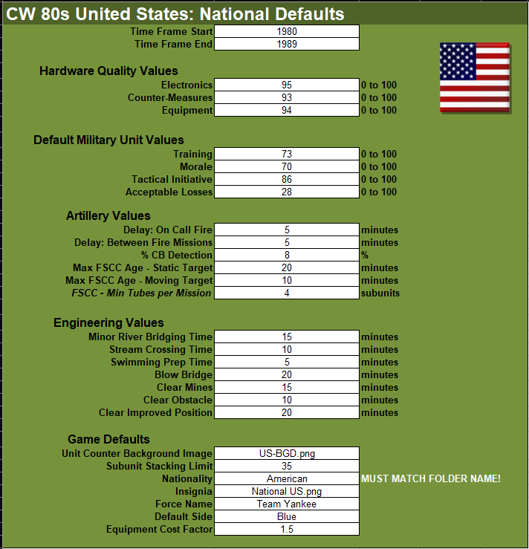These values represent certain abilities or game engine defaults which are specific to a given country in the game. Changes made to many of the values on this tab of the spreadsheet will impact on the overall play of units from this country.

## Time Frame Start/End

Sets the time frame reflected by this data set. Scenarios created in the editor must be set for this period. These are usually in ten-year increments, but in the case of recent modern data may cover a larger span of years.

## Hardware Quality Values

Relative measure of the technical competency of a country’s electronics and mechanical equipment. These values are used during certain engagements as a minor adjustment to characteristics found in the systems and units data tables.

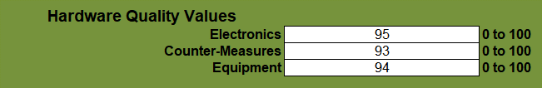

### Electronics

Quality of electronic equipment such as sensors, radios, etc. used by a force (Quality set as on a scale of 0-100 with 100 being the best).

### Countermeasures

Quality of electronic countermeasures equipment for a force (Quality set as on a scale of 01-100 with 100 being the best).

### Equipment

Quality of general equipment not covered above for a force (Quality set as on a scale of 0-100 with 100 being the best).

## Default Military Unit Values

These are relative measures of a counties general/average fighting force soft factors (human element of the force). These factors influence several variables during simulation dealing with combat, orders, and command. These values can be set to different values for units in the Scenario Editor to reflect better or worse than average forces.

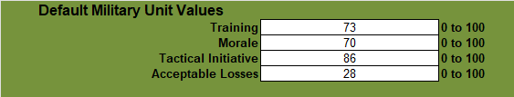

### Training

An identifier representing the average amount of training received. Scale of 0 (Untrained) to 100 (Elite) with 100 being the best.

### Morale

A number from 0 to 100 (best) represents the mental state of the unit at the beginning of the scenario. This value can drop during a battle and recover to a maximum of the preset value.

### Tactical Initiative

An indication of the unit’s freedom and initiative to assess the situation and act on their own at times in opposition to their given orders. The values range from 0 (No local initiative-stick with given orders) to 100 (total freedom locally). Unit SOPs (Standard Operating Procedures) can override this global setting.

### Acceptable Losses

Sets the force’s determination and ability to stand and fight and accept losses. The values range from 0 (No loss acceptance) to 100 (fight to the last man). Unit SOPs (Standard Operating Procedures) can override this global setting.

## Artillery Values

There are several settings to control the overall mechanics of a nation’s artillery support system. Values apply to both human control of support assets and the AI’s FSCC role if automated.

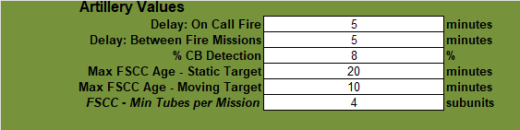

### Delay: On Call Fire

Additional Delay in minutes for the arrival of on call fire mission beyond the the delay for the command loops of spotter to battery.

### Delay: Between Fire Mission

Delay in minutes between fire missions. This time reflects the time required to set the target locations of a new fire mission.

### % CB Detection (Legacy)

The chance that an enemy fire mission will be detected, located, and possibly attacked by counter battery. This is your chance to be detected by the enemy and engaged based on SOP and shoot and scoot tactics.

**NOTE:** This parameter will be replaced in the future with actual counter-battery capability with sensors and then passed to artillery units set to counter-battery operations.

### Max FSCC Age-Static Target

The time that a static (non-moving) target will remain in the FSCC queue once it is detected. The shorter the time, the more fresh the target mission calls will be.

### Max FSCC Age-Moving Target

The time that a moving target will remain in the FSCC queue. The shorter the time, the more up-to-date the mission targets will be, and the less likey rounds will hit an empty target hex.

### FSCC-Min Tubes per Mission

The minimum number of artillery tubes that an artillery battery must have available (not knocked out or destroyed) in order to execute an FSCC attack request.

## Engineering Values

These values cover various engineering functions and the length of time to perform these actions by capable Engineering type units.

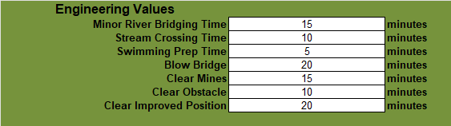

### Minor River Bridging Time

This is the time it takes in minutes to lay a bridge of a hex side water obstacle with a short-span bridge.

### Stream Crossing Time

This is the time it takes in minutes to find and ford a shallow stream.

### Swimming Prep Time

This is the time it takes in minutes to prepare vehicles to swim a water obstacle.

### Blow Bridge

This is the time it takes in minutes to prepare a bridge for demolition and render the crossing impassable.

### Clear Mines

This is the time it takes in minutes to clear lanes in a minefield hex or edge obstacle so units can pass without loss.

### Clear Obstacle

This is the time it takes in minutes to clear obstacles (wire, logs, abatis, etc.) in a hex or edge so units can pass without delay.

### Clear Improved Position (IP)

This is the time it takes in minutes to remove and enemy improved position so it cannot be used by the enemy for added defense.

## Game Defaults

Important game related values that set certain use defaults or global parameters used by the game engine.

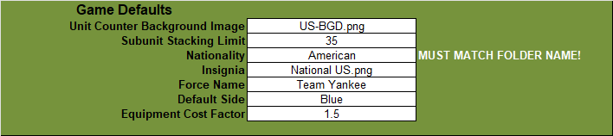

### Unit Counter Background Image

The default graphic file in the [Nations’s Data]/Backgrounds folder used as the counter background in-game for all units.

### Subunit Stacking Limit

The maximum number of subunits that the Nation’s forces are allowed to place in a single hex as a volume control measure.

### Nationality

This must be a unique name for a given Nationality and MUST be the same name of the Nation’s Folder in the Modules/Common/Data folder of the simulation. You may have any number of National XLS data files in the folder as you like as long as they have a unique filename and have the correct Nationality entry (see below).

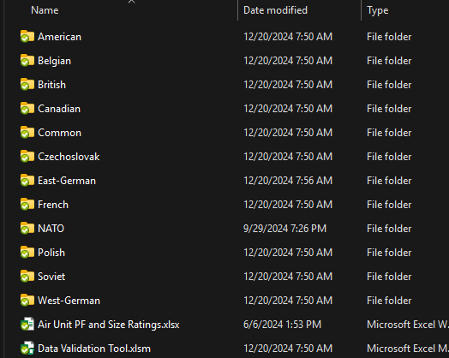

**WARNING:** The Nationality entry MUST match the name used for the folder or the game engine will not see or use the data file or possibly crash the game.

### Insignia

Default Graphic file in the Country’s Data folder for this force’s insignia. Insignia can be changed in the scenario editor.

### Force Name

Default name for the user’s Force. The name can be changed in the scenario editor.

### Default Side

Select **“**Blue” for Player 1 and “Red” for Player 2. This detemines the “side” the National data files will show up on in the scenario editor.

**NOTE:** The number of availible sides is a feature we plan to increase in the future and this value may change or be depreicated.

### Equipment Cost Factor

This factor is multiplied with the cost of equipment/subunit for that side to determine the victory points that are awarded for the lost of said equipment/subunit. Most NATO (Blue) Nations will be above 1.0 and most Op-For (Red) countries will be below 1.0. This is a global VP cost multiplier and can be used to balance out force cost ratios.

# Command

These values represent certain size, naming, or command and control parameters specific to a given country in the game. Changes made to values on this spreadsheet tab will impact the overall command cycle of units from this country.

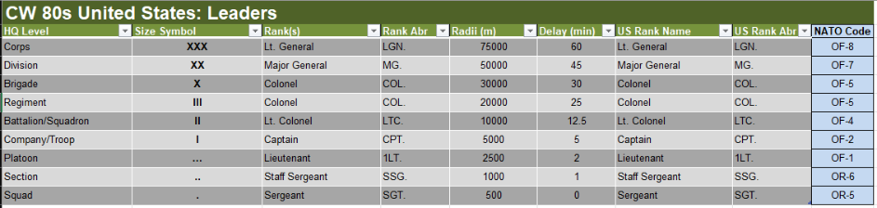

## HQ Level

Size of the formation with respect to the HQ used to control it. The simulation covers Sections (smallest) up to Corp level HQ formations.

## Size Symbol

This is the type of NATO standard size symbol related to the size of the formation the HQ units’ commands.

## Rank(s)

This is the Nation’s most common rank for the person in charge of the HQ at the specific level/size.

## Rank Abr

This is the abbreviation of the rank for this size of HQ and is used in the game with the Commander’s name (randomly generated from the Surnames Table).

## Radii (m)

This is the basic command and control radius of the particular HQ on the map in the game. Units outside of this radius can suffer additional delays in orders or supply.

## Delay (Min)

This is the basic order delay time from local HQ to units in minutes. The further a unit needs to move out of its radius (5.5) the delay increases as orders need to flow to a next higher HQ. Delay can also be impacted by electronic warfare and readiness (fatigue of forces and HQs).

## US Rank Name

Added a column for the US Rank Name equivalent. This can be toggled on/off in the game options to choose between the native language rank name and US rank name. Not shown in the picture.

## US Rank Abr

Added a column for the US Rank Abbreviation equivalent. This can be toggled on/off in the game options to choose between the native language rank name and US rank name. Not shown in the picture.

## NATO Code

The values match up to the NATO standard code for the level of command/rank. Shown for reference only.

# Formations

This is where the whole process comes together. The Formations Tab is where you assemble the units and formations used in the scenario editor to build your orders of battle.

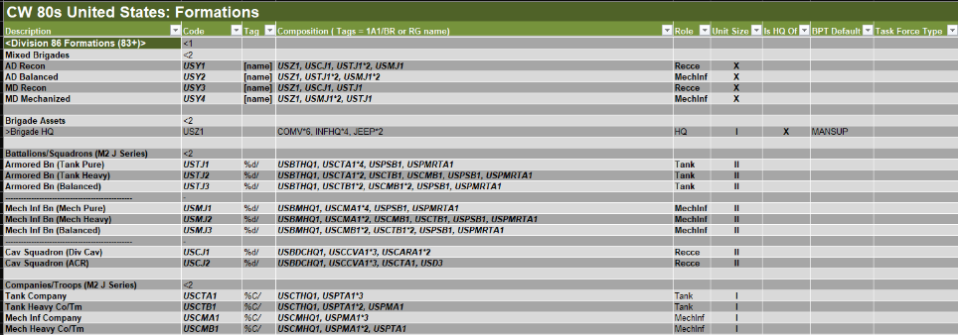

## Description (Format Use)

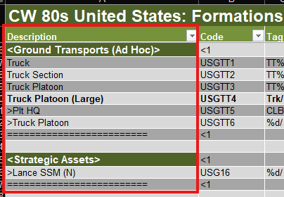This field has several uses for providing OOB formation names, names for formation elements, cues for node indenture, visible separators between main and subgroups of formations and elements, and identifiers or names for major groups in the formation spreadsheet table.

All these elements are used to provide the layout of selectable formations and elements of formation in the game’s scenario editor. These primary types are as follows:

### Major Formation Identifiers

Found in the chevron brackets” < >” These are major formation group names that form major OOB elements like “<Division 86 Formation>” or “<OMG/Brigade (86+)>” or "<Brigade Assets>" and “<1” in the Code field (see Section 17.3 below). They have no other information in the row apart from Mission Filters. If the major formation has a date of use, you can add it in brackets as the “(86+)” above to help players choose the correct formations based on the scenario date.

**NOTE:** The scenario date selected does not cause the formations list to filter in any way. The user must remember and use the correct formations if there are date-based options.

### End Major Group Fields

This is a string of equal signs “==============” in the Description field and “<1” in the Code field (see Section 17.3 below) that shows up in the scenario editor to separate major groups of formations. The “<1” code will place this marker at the top node level. There is no [+] for expansion on this separator. This Description code is what closes the major section in the Scenario Editor and creates an expandable note in the formation selection tree.

**WARNING:** If this End field is missing, following sections of formation data may not show or show correctly in the Scenario Editor.

### Type Formation Identifiers

If you need to have an additional descriptive breakdown such as “Battalions” or “Squadrons”, you can add those identifiers in the description field. This also has no other information except for the option of a Mission Filter (when available).

### Minor Group Separators

This is a string of minus signs “---------------------” in the Description field that shows up in the scenario editor to separate minor groupings of formations. There needs to be a single minus sign (“-“) in the Code field alongside the string in the description field.

### Blank Lines

A fully empty row can be used for the readability of the Formation Table. Optional, but helpful to stay organized. Blank lines are not visible in the Scenario Editor. Any stray text in any field can cause a problem with the Scenario Editor look and data parsing.

## Description (Information Use)

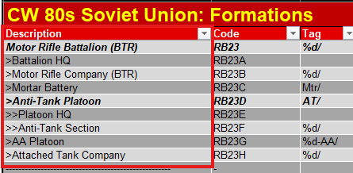To put together an OOB, the names and use of the node indent symbols “>”, “>>”, and “>>>” allow the Scenario Editor to generate an indented list based on the indents and the names. The above Motor Rifle Battalion is comprised of a “>”Battalion HQ, “>”Motor Rifle Company, “>”Mortar Battery, “>”Anti-Tank Platton, “>”AA Section, and “>” Attached Tank Company. The Anti-Tank Platoon has a third level breakdown with the “>>” noted platoon element entries.

## Code

This **MUST** be a unique identifier for each formation element in the formations table that has information in the Composition Field of the table. It can be an alphanumeric construction with symbols but no spaces. These tags are used in formation compositions, so keeping them short, but identifiable is helpful.

These Codes are also used in formation compositions to build larger formation groups.

### Indented Node Code

The ability to control the level of indenture of the collapsible nodes in the OOB section of the Scenario Editor has been added. This improves both the grouping and readability of the data. Eight levels of indenture are usable, and they are “<1” through “<8”. They must be placed in the Code field of a Major or Type Formation Identifier field.

In the example below, the indent codes of “<1”, “<2”, and “<3” are placed to create the indented open/close node points for the various formations. In this case, the Air Support formations. The Indent Codes are circled in red.

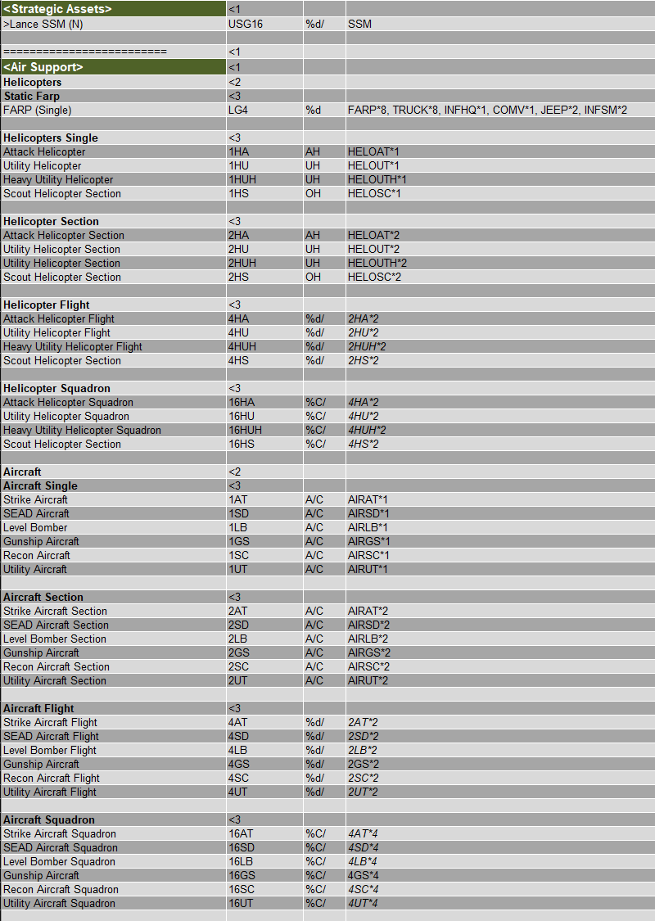

Next is an image of how that structure appears in the game’s Scenario Editor.

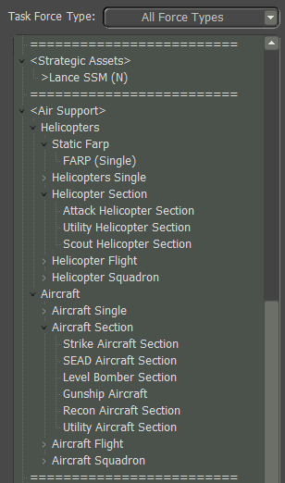

## Tag

These are alphanumeric names that appear as part of a unit’s identification in-game. Such as “4/A/2-5 Cav”. These names can be renamed in the scenario editor if they do not auto generate in a way that works for your scenario. There are two special codes you can use.

* %C/ - This will provide an incrementing capitol letter. This is good for adding the Company Identifier for most NATO style units such as the “A/” in the example above.
* %d/ - This with provide and incrementing number starting at “1” and is good for most NATO Platoon Identifiers. This would be the “4/” in the example above.

Reviewing the various data file entries will give you a sense of what can be done. These unit identifiers should be as short as practical to be seen on a counter. The full name will appear in other information sources/panels (like the Subunit Inspector and Staff Reports) in full.

## Composition

The Composition entry is used to generate the various orders of battle for a given nation’s forces. There are two types of Composition constructs: Units and Formations.

To build a Unit Composition, you will need to use the CompID of a particular unit and then a “*” symbol with the count of those units (if there is only a single unit, the “*1” can be omitted).

To build a Formation Composition, you will need to use the Code in column two of a particular formation element and then a “*” symbol with the count of those formation elements (if there is only a single Code, the “*1” can be omitted).

**WARNING:** You cannot mix CompIDs and Codes in the same line or it will crash the game. Data Validation will catch most of these errors when used.

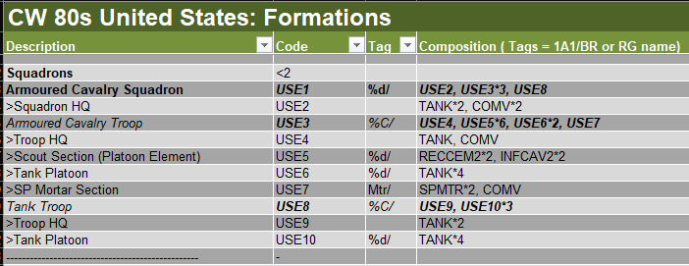

## Role

The Role identifier is a set value that describes the overall use of the particular formation element and is used by the game’s AI to control behavior. Refer to Section 10 above, for a list of all valid Roles.

## Unit Size

This is the NATO size symbol corresponding to the size of the formation element in the row, not the overall size of the whole formation. These symbols will show up on the counters in-game.

**NOTE:** For a Platoon, it is three periods and not an ellipse. Excel is extremely helpful in turning three periods into an ellipse for you. This will not work in the game and will get flagged in the Validation Program. To change this behavior, go into Excel’s Options, Proofing, click AutoCorrect Options, scroll the Replace Text as you type window and find the three periods replaced with the ellipse and Delete that entry. You are good to go now.

## Is HQ Of

If your formation row entry is an HQ structure, you will then need to assign a NATO size symbol for the size of the formation it commands (not the size of the unit itself, which is covered in the Size field).

## BPT Default

These codes are used by the game engine to set various AI parameters and behaviors based on the composition of the formation this code is used on. A list of valid codes can be found in Section 11 above.

**NOTE:** This feature is currently under implementation and the full effect may not be present in game code, but the Data Validation Program has the current list of codes and can detect bad or unneeded codes in the formation table.

## Task Force Type

These codes are used by the Scenario Editor to filter out certain mission types of units. This allows the user to zero in on certain formations they need to add to the scenario. Valid Task Force Types can be found in Section 9 above. Task Force Types should be used on all formations you want to group and the Formation Identifiers and separators to keep the look and information clear.

You can assign more than one filter to a row if they are comma- delimited. This allows for certain formations to appear in multiple Task Force Types. Check the supplied data files to see examples of Task Force Type use.

**NOTE:** This feature is not currently active in the game, and we may at some point remove it.

## Formation Format Best Practices

# Description (IUnits

The Units tab is where each specific platform (aircraft, tank, infantry squad, etc.) is defined by a list of values, characteristics and pointers to other data used by the game engine to operate in the simulation.

## SUTag

The SUTag is an alphanumeric entry that must be a unique identifier for each entry. Our basic format is a two-character letter code for the country and then an integer value like “WG23”, or “UK357”.

***WARNING:*** *Once you set these values for a dataset and use it in the scenario editor, any edits, or reorders of the SUTags that break the initial SUTag-Platform relationship will cause existing scenarios to load bad data if you update a scenarios data with a corrupted dataset with remapped SUTags. If you need to add more platforms between entries (for data consistency/appearance) You should add to the code with additional alphanumeric characters. For example, if you had “UK357” and “UK358” in your list and wanted to add in two more variants, you can add rows to the spreadsheet in between them and use SUTags like “UK357A” and “UK357B”. You could also add a new value greater than the largest one in the SUTag list.*

## Name

This is the given identification of a specific platform or squad as used by its nation. For example, “M1A1 Abrams”, “T-80BV, “Challenger”, etc.

## NATO Designation

This is a platform’s specific NATO designation, if one exists. For example, SA-3 Goa (for an S-125 Neva). This field is included to allow for most OpFor hardware of Russian origin to carry its given NATO designated code and name. It can also be used for alternate names used by countries for other countries’ hardware.

## PICID

This is the filename of the unit’s silhouette image or NATO standard icon for squads. The images are in Modules\Common\Data\Common Folder. Images specifications can be found in the Game Engine Modifications document.

## NATOPIC

This is the filename for the NATO standard icon for all units. The images are in Modules\Common\Data\NATO Folder. Images specifications can be found in the Game Engine Modifications document.

## Description

This is a concise description explaining the platform’s type and function. For example, “Main Battle Tank”, “Wheeled APC”, etc. This description is displayed in the Sub-Unit Inspector and in several other information panels.

For aircraft, drones, and helicopters, the description is followed by a dash and then a list of weapon types carried to help the user see the various loadouts. As an example, the US F-16D Close Air Support aircraft has a Description of “CAS Aircraft - Can/FAE/IB” denoting the aircraft has a Cannon, Fuel Air Explosive bomb, and Iron Bombs as its weapons.

## SU Type

The Platform Type (Subunit Type or SU Type) is the unique classification of the unit based on the values found in Section 4 above.

***WARNING:*** *A unit MUST have one of these codes for the game to recognize it and employ it properly. Users cannot add their own SU Types to the game as it requires supporting code.*

## CompID

Composition ID or CompID is a user generated value used to help define types and subtypes of platforms that are used in the creation of formations. In most cases, this is the same as the SU Type.

In certain cases, if you need to highlight or set apart a platform unit(s) you can make your own alphanumeric identifier. This CompID then can be used in a formation composition and only those units with the particular CompID will show in the selection screen in the Scenario Editor.

## First Year Avail

This is the year in which the unit entered service in useful numbers. Based on scenario start date, any unit whose start date is greater than the scenario date will not display in the selection window.

## Last Year Avail

This is the last year in which the unit served in useful numbers. Based on scenario start date, any units whose end date is less than the scenario date will not display in the selection window.

## Crew

This is the number of personnel used to man a particular platform or system. This does not include passengers.

## Mobility

This value indicates the type of propulsion/movement used by a particular unit. Refer to 12 above for the valid types. This value is used in several movement calculations and ability checks when units move in the game.

## Speed

This is the top speed (in km/hr) of the platform. Movement on the ground for most types of movement orders is much less than the maximum speed entered as the game considers slower movement rates when in a combat area and based on the type of movement order the units are following. Speed for aircraft, drones, and helicopters will factor in its defensive capability in combat engagements.

## Transport (Organic)

For a positive value, this is the number of passenger units that can be loaded on a particular platform. For a negative number, this is the relative amount of space taken up by the unit to be transported. To see if a unit can be loaded on a transport, you add a positive transport value to the negative transport value(s) and must be greater than or equal to zero. For example, you can load a US HMMWV (Transport = 2) with two Sniper Teams (Transport = -1) or one Scout unit (Transport = -2).

**NOTE:** Organic Transport is used for mechanized forces to keep IFVs and troops in a cohesive unit. We have added a Tactical Transport (TT) feature for ad-hoc transport of troops and also to support air assault operations.

## Size

This factor is a relative measure of volume for the unit in question. Size is used in both spotting and combat to modify certain calculations.

For leg units this is equal to 0 for 1-4 Crew, 1 for 5-8, and an additional +1 for every 4 Crew.

For vehicles and weapon systems, find a unit of similar size in an existing listing and use that number.

For Air Units, please use the Aircraft Values Spreadsheet to get the size rating.

**NOTE:** This new attribute is still being worked on and may see some values change as we improve the method of calculations (especially for ground vehicles.

## Mass

Mass is the weight of the vehicle or squad in pounds (US). Squads are based on 250 pounds per person, weapon, and engineering teams at 300 pounds a person, and vehicles based on empty weights rounded to the nearest 100 pounds. This value is used to determine if the unit can be carried by a transport vehicle (via Tactical Transport) or how many can be carried based on the transport’s Internal and External Weight limits. All Units require a Mass value.

## IntTrp

Internal Troops (IntTrp) is the maximum number of troops that a transport can carry internally. This value is only used on units that are using the Tactical Transport feature and not an organic transport unit type.

## IntWt

Internal Weight (IntWt) is the maximum weight that a transport can carry internally. This value is only used on units that are using the Tactical Transport feature.

## ExtTrp

External Troops (ExtTrp) is the maximum number of troops that a transport can carry externally. This value is only used on units that are using the Tactical Transport feature and not an organic transport type.

## ExtWt

External Weight (ExtWt) is the maximum weight that a transport can carry externally (like a sling load on a helicopter). This value is only used on units that are using the Tactical Transport feature.

## FC/RF

This is a relative measure of a unit’s Fire Control/Range Finder (FC/RF) systems. The range of value is 0 (no system) to 20 (future ultra-AI sensor fusion). This value is used in combat when working out the chance to hit calculations.

## Stab

The Stab (Stability) value is used to rate a unit’s ability to fire accurately at a moving target while moving itself. Stab value ranges from 0 (no stability system) to 10 (fully stabilized, accuracy remarkably close to static target and static shooter). Values in the middle can be used for units with lesser stabilization systems.

For air SU Type systems, AIRAT and AIRSD are set to 5, AIRLB are set to 7, AIRGS are set to 9, AIRUT are set to 3, Drones (HELOSC/AIRAT) are set to 8, Unarmed HELOs are a 0, Armed are 5 through 9 depending on unit use and technology level. Most purpose-built attack helicopters will be an 8.

## The Characteristics Lists

There are three columns in the data file devoted to lists of parameters. The first three deal with Abilities, Defenses, and Equipment Platform Characteristics. As you can see from the image below, these lists can be rather lengthy.

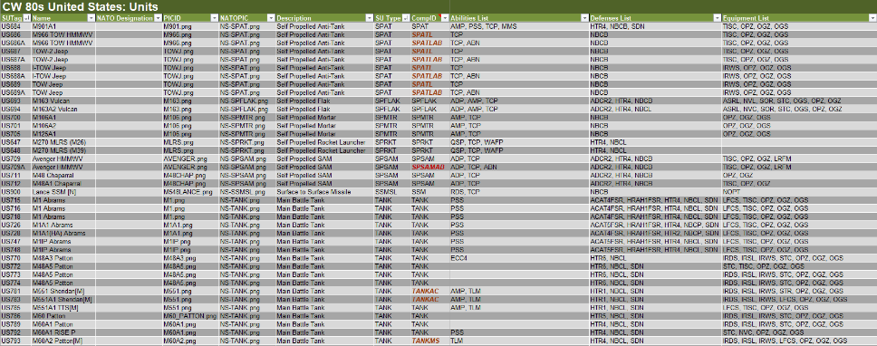

### Abilities List

These Characteristic Codes are broken down into four functional groups and the lists and descriptions of these codes can be found in Section 5.1 above. These groups are Abilities-Engineering, Abilities-General, Abilities-Transport, and Abilities-Logistical. If your unit in question has any of the abilities found in these lists, you add them to a comma delimited list in the Abilities List spreadsheet field.

### Defenses List

These Shared Characteristic Codes are broken down into three functional groups and the lists and descriptions of these codes can be found in Section 5.1 above. These groups are Defenses-Abilities, Defenses-Countermeasures, and Defenses-Protection. If your unit in question has any of the defenses found in the lists, you add them a comma delimited list in the Defenses List spreadsheet field. A number of these Shared Characteristic Codes are used in setting the levels of unit protection and will have additional explanation in Section 19 below of this document.

### Equipment List

These Shared Characteristic Codes are broken down into two functional groups and the lists and descriptions of these codes can be found in Section 5.1 above. These groups are Equipment-Receivers, Equipment-Sensors, Equipment-Target Acquisition, and Equipment-Weapon Locating Sensors. If your unit in question has any of the equipment found in the lists, you add them a comma delimited list in the Equipment List spreadsheet field.

## Integrated Weapons List

This final list is different from the other three as it is a listing of the weapons/systems carried and the amount of ammunitions/uses each weapon/system has, in a comma delimited list. There are two types of entries for the weapons list depending on is a weapon/system has variable munition or not. The setup of the information is as follows.

### System with Single Ammo Allocation

The format is the WEAPTAG code and then the “*” sign and a value for the amount of ammunition. The amount of ammunition is rounds for items that fire single shot (artillery guns, tank guns, PGMs, ATGMs, etc.) or in bursts for multi-round shooting weapons.

The following is an example of an AH-64A Apache Attack Helicopter. In this case, with an autocannon with 58 bursts and 4 Hellfire mounts with 4 ATGMs on each mount:

AUCN9*58, ATGM10*4, ATGM10*4, ATGM10*4, ATGM10*4

### System with Munitions

The format is the WEAPTAG code and then the “:” sign followed by a semi-colon (;) separated listing of munitions with AmmoTypeID followed by the “*” sign and number of rounds carried of that type of munition. This gun system is separated by a common to other systems in the listing such as the machine guns in this example.

The following is an example of a M551 Sheridan with multiple rounds for the tank gun. In this case, with a tank gun with three types of munitions for the gun (6 HE rounds, 12 HEAT rounds, and 11 ATGM rounds) for the TGN14M weapon system and two machine guns (AAA11 and VSW3) with single ammo allocations:

TGN14M: TGN14M_HE*6; TGN14M_HEAT*12; TGN14M_ATGM*11, AAA11*90, VSW3*120

### Ammunition Allocation

## PF (Protection Factor)

Depending on the type of unit, the Protection Factor (PF) represents the unit’s basic armor or toughness when hit with weapons fire. There are several Characteristics that augment the PF rating of certain units, and the determination of those Characteristics is covered in more detail in Section 19 below.

### PF for Soft Units

If the unit is leg mobile (squads and teams), towed or crew served weapon (Field gun, anti-tank gun, etc.), static weapon system (SAMWS), or Decoy the PF rating for the unit is 0. These units gain protection based on the cover they are in and their orders state.

### PF for Air Units

All Air units have a PF generated by a secondary spreadsheet called Air Unit PF Ratings. You will need to know the Empty Weight in pounds, number of Exhaust Ports (engines or engines and VTOL exhaust ports), is the unit a Transport (they have larger size per pound since they carry cargo), and Engine Type (p-Prop, r-Rotor, j-Jet/Rocket). You can add more air units to the spreadsheet as needed. See Section 20 for more detailed instructions.

### PF for Ground Vehicle Units

The new game engine works on a 1 PF per 10mm of RHA equivalent kinetic armor protection. For most lightly armored vehicles this will be 1 to 5 (10 to 50mm protection). To calculate a PR rating for a more heavily armored AFV you will want to have data on the frontal thickness of hull and turret armor versus kinetic rounds in millimeters of RHA. Chemical/HEAT and ERA/NERA type augmentations will be covered in Section 19 below of this document. You may need to make some estimation of the value if the data is more detailed by area information. With values for both turret and hull frontal in millimeters or just hull if no turret is present, divide by 10 to get the base PF ratings. If there is a turret, use the turret value for the base PF, else use the Hull PF value for the PF Rating. Hold on to the Hull PF value if a turret present as it will be used in Section 19 below calculations.

# Defining Armor Value and Specials

Based on the value(s) obtained in Section 18.25.3 above either a Hull PF or a Turret PF and associated Hull PF was generated. In the case of a pure hull design the Hull PF rating was entered in the data sheet. If a turret was present on the AVF platform the Turret PF rating was entered in the data sheet. This is a very basic kinetic resistance value, and we use several Characteristics to account for the other more advanced aspects of armor coverage. The following sections will cover these additional aspects.

## Hull to Turret Ratio (HTR)

The HTR Characteristics are located in the Defensive Abilities listing and are defined in the following table. This code allows the game engine to calculate a PF for the hull based on the Turret PF and this code.

|  |  |  |
| --- | --- | --- |
| **Code** | **Unit Special Description** | **Notes** |
| HTR1 | Hull to Turret Ratio, Type 1 | Ratio is <.60 for Hull PF / Turret PF rating, -50% to PF adjustment for hull hits |
| HTR2 | Hull to Turret Ratio, Type 2 | Ratio is .60 to .75 for Hull PF / Turret PF rating, -30% to PF adjustment for hull hits |
| HTR3 | Hull to Turret Ratio, Type 3 | Ratio is .75 to .90 for Hull PF / Turret PF rating, -15% to PF adjustment for hull hits |
| HTR4 | Hull to Turret Ratio, Type 4 | Ratio is .90 to 1.10 for Hull PF / Turret PF rating, no adjustment for hull hits |
| HTR5 | Hull to Turret Ratio, Type 5 | Ratio is 1.10 to 1.25 for Hull PF / Turret PF rating, +15% to PF adjustment for hull hits |
| **Code** | **Unit Special Description** | **Notes** |
| HTR6 | Hull to Turret Ratio, Type 6 | Ratio is 1.25 to 1.40 for Hull PF / Turret PF rating, +30% to PF adjustment for hull hits |
| HTR7 | Hull to Turret Ratio, Type 7 | Ratio is >1.40 for Hull PF / Turret PF rating, +50% to PF adjustment for hull hits |

To determine which value to use, calculate Hull PF / Turret PF and consult the range in the Notes Field. If the value falls into the range of HTR4 (near 1.0) you do not need to add this special to the Defenses List of the unit.

## Advanced Composite Armour (ACA)

The ACA Characteristics are in the Defensive Protection listing and are defined in the following table. This code allows the game engine to augment the PF rating against HEAT based rounds based on location (hull or turret) and aspect (Front, Side, Rear, and Top).

**NOTE:** You can assign more than one of these codes in the Defenses List of a unit if there is a variable level of coverage based on location and aspect.

|  |  |  |
| --- | --- | --- |
| **Code** | **Unit Special Description** | **Notes** |
| ACAH1 | Advanced Composite Armour (Effectiveness 1) | <1.25 ratio, Hull, Aspect Coded (F/S/R/T) |
| ACAH2 | Advanced Composite Armour (Effectiveness 2) | <1.25 : 1.5 ratio, Hull, Aspect Coded (F/S/R/T) |
| ACAH3 | Advanced Composite Armour (Effectiveness 3) | <1.5 : 1.75 ratio, Hull, Aspect Coded (F/S/R/T) |
| ACAH4 | Advanced Composite Armour (Effectiveness 4) | <1.75 : 2.0 ratio, Hull, Aspect Coded (F/S/R/T) |
| ACAH5 | Advanced Composite Armour (Effectiveness 5) | >2.0 ratio Hull, Aspect Coded (F/S/R/T) |
| ACAT1 | Advanced Composite Armour (Effectiveness 1) | <1.25 ratio, Turret, Aspect Coded (F/S/R/T) |
| ACAT2 | Advanced Composite Armour (Effectiveness 2) | <1.25 : 1.5 ratio, Turret, Aspect Coded (F/S/R/T) |
|  |  |  |
| **Code** | **Unit Special Description** | **Notes** |
| ACAT3 | Advanced Composite Armour (Effectiveness 3) | <1.5 : 1.75 ratio, Turret, Aspect Coded (F/S/R/T) |
| ACAT4 | Advanced Composite Armour (Effectiveness 4) | <1.75 : 2.0 ratio, Turret, Aspect Coded (F/S/R/T) |
| ACAT5 | Advanced Composite Armour (Effectiveness 5) | >2.0 ratio Turret, Aspect Coded (F/S/R/T) |

To determine which value to use, a calculation of the ratio of the HEAT resistance to Kinetic resistance for the location and aspect needs to be done and then compared to the table to get the correct basic ACA code. To complete an ACA code, add the Aspect Letters after the 1-5 effectiveness value.

For example, if you have an “ACAH3” (hull ACA with a ratio between 1.5 and 1.75) and it covers front and side only the full code will be “ACAH3FS”.

## Explosive Reactive Armour (ERA)

The ERA Characteristics are located in the Defensive Protection listing and are defined in the following table. This code allows the game engine to augment the HEAT or Kinetic AP penetration value of an incoming round based on location (hull or turret) and aspect (Front, Side, Rear, and Top). You can also use these codes for NERA protection as well.

**NOTE:** You can assign more than one of these codes in the Defenses List of a unit if there is a variable level of coverage based on location and aspect.

|  |  |  |
| --- | --- | --- |
| **Code** | **Unit Special Description** | **Notes** |
| ERAH1 | ERA - Hull, Type 1, Aspect (Front/Side/Rear/Top) | Explosive reactive armor, early type, CE only - Kontakt-1, Hull, Aspect Coded (F/S/R/T) |
| ERAH2 | ERA - Hull, Type 2, Aspect (Front/Side/Rear/Top) | Explosive reactive armor, early type, CE only - Kontakt-3, Hull, Aspect Coded (F/S/R/T) |
| **Code** | **Unit Special Description** | **Notes** |
| ERAH3 | ERA - Hull, Type 3, Aspect (Front/Side/Rear/Top) | Explosive reactive armor, late type, CE/KE - Kontakt-5 (85+), Hull, Aspect Coded (F/S/R/T) |
| ERAH4 | ERA - Hull, Type 4, Aspect (Front/Side/Rear/Top) | Explosive reactive armor, late type, CE/KE - Relikt (06+), Hull, Aspect Coded (F/S/R/T) |
| ERAT1 | ERA - Turret, Type 1, Aspect (Front/Side/Rear/Top) | Explosive reactive armor, early type, CE only - Kontakt-1, Turret, Aspect Coded (F/S/R/T) |
| ERAT2 | ERA - Turret, Type 2, Aspect (Front/Side/Rear/Top) | Explosive reactive armor, early type, CE only - Kontakt-3, Hull, Aspect Coded (F/S/R/T) |
| ERAT3 | ERA - Turret, Type 3, Aspect (Front/Side/Rear/Top) | Explosive reactive armor, late type, CE/KE - Kontakt-5 (85+), Turret, Aspect Coded (F/S/R/T) |
| ERAT4 | ERA - Turret, Type 4, Aspect (Front/Side/Rear/Top) | Explosive reactive armor, late type, CE/KE - Relikt (06+), Turret, Aspect Coded (F/S/R/T) |

In order to determine which value to use, select the type that best matches the performance of the listed types for the location (hull or turret) and aspect. To complete an ERA code, add the Aspect Letters after the 1-4 effectiveness value.

For example, if you have an “ERAH4” (hull ERA with a performance like Relikt) and it covers front and side only the full code will be “ERAH4FS”.

## HEAT Resistant Armour (HRA)

The HRA Characteristics are located in the Defensive Protection listing and are defined in the following table. This code allows the game engine to augment the HEAT PF value of the armor for systems with enhanced HEAT protection versus a lighter kinetic protection (hull or turret) and aspect (Front, Side, Rear, and Top). This type of armor is mainly found on IFVs and APCs.

NOTE: You can assign more than one of these codes in the Defenses List of a unit if there is a variable level of coverage based on location and aspect.

|  |  |  |
| --- | --- | --- |
| **Code** | **Unit Special Description** | **Notes** |
| HRAH1 | HEAT Resistant Armor-Hull, Type 1, Aspect (F/S/R/T) | Reduced HEAT - >3 and <= 6 ratio (C/K), Hull, Aspect Coded (F/S/R/T) |
| HRAH2 | HEAT Resistant Armor-Hull, Type 2, Aspect (F/S/R/T) | Reduced HEAT - >6 and <= 9 ratio (C/K), Hull, Aspect Coded (F/S/R/T) |
| HRAH3 | HEAT Resistant Armor-Hull, Type 3, Aspect (F/S/R/T) | Reduced HEAT - >9 and <= 12 ratio (C/K), Hull, Aspect Coded (F/S/R/T) |
| HRAH4 | HEAT Resistant Armor-Hull, Type 4, Aspect (F/S/R/T) | Reduced HEAT - >12 and <= 15 ratio (C/K), Hull, Aspect Coded (F/S/R/T) |
| HRAH5 | HEAT Resistant Armor-Hull, Type 5, Aspect (F/S/R/T) | Reduced HEAT - >15 ratio (C/K), Hull, Aspect Coded (F/S/R/T) |
| HRAT1 | HEAT Resistant Armor-Turret, Type 1, Aspect (F/S/R/T) | Reduced HEAT - >3 and <= 6 ratio (C/K), Turret, Aspect Coded (F/S/R/T) |
| HRAT2 | HEAT Resistant Armor-Turret, Type 2, Aspect (F/S/R/T) | Reduced HEAT - >6 and <= 9 ratio (C/K), Turret, Aspect Coded (F/S/R/T) |
| HRAT3 | HEAT Resistant Armor-Turret, Type 3, Aspect (F/S/R/T) | Reduced HEAT - >9 and <= 12 ratio (C/K), Turret, Aspect Coded (F/S/R/T) |
| HRAT4 | HEAT Resistant Armor-Turret, Type 4, Aspect (F/S/R/T) | Reduced HEAT - >12 and <= 15 ratio (C/K), Turret, Aspect Coded (F/S/R/T) |
| HRAT5 | HEAT Resistant Armor-Turret, Type 5, Aspect (F/S/R/T) | Reduced HEAT - >15 ratio (C/K), Turret, Aspect Coded (F/S/R/T) |

To determine which value to use, a calculation of the ratio of the HEAT resistance to Kinetic resistance for the location and aspect needs to be done and then compared to the table to get the correct basic HRA code. To complete an HRA code, add the Aspect Letters after the 1-5 effectiveness value.

For example, if you have an “HRAT3” (turret HRA with a ratio between 9.0 and 12.0) and it covers front, side, and top, the full code will be “HRAT3FST”.

## Skirt Armour (SKT)

The SKT Characteristics are located in the Defensive Protection listing and are defined in the following table. This code allows the game engine to augment the HEAT or Kinetic AP penetration value of an incoming round based on location (hull or turret) and considered to be Side and Rear only aspects.

**NOTE:** You can assign more than one of these codes in the Defenses List of a unit if there is a variable level of coverage based on skirt type and location of coverage.

|  |  |  |
| --- | --- | --- |
| **Code** | **Unit Special Description** | **Notes** |
| SKTHL | Armoured Skirt Hull sLats | used for slat style skirts that degrade AP and HEAT weapons |
| SKTHP | Armoured Skirt Hull Plate | used for plate style skirts that degrade AP and HEAT weapons |
| SKTHS | Armoured Skirt Hull Spaced | used for spaced plate style skirts that degrade AP and HEAT weapons |
| SKTHW | Armoured Skirt Hull Wire | used for wire style skirts that degrade AP and HEAT weapons |
| SKTTL | Armoured Skirt Turret sLats | used for slat style skirts that degrade AP and HEAT weapons |
| SKTTP | Armoured Skirt Turret Plate | used for plate style skirts that degrade AP and HEAT weapons |
| SKTTS | Armoured Skirt Turret Spaced | used for spaced plate style skirts that degrade AP and HEAT weapons |
| SKTTW | Armoured Skirt Turret Wire | used for wire style skirts that degrade AP and HEAT weapons |

To determine which value to use, select the type of skirt that best represents the setup on the unit.

## Values for Side and Top/Rear

There are two internal global values used in the game. For a side aspect shot the basic PF value is multiplied to 0.46 and for the top and rear time 0.21. Both numbers are based on looking at many post WW2 tanks and these were the majority breakpoints for those aspects.

# Air Unit Size and PF Rating Calculator

As noted earlier in this document. The Size and PF rating for Air Units is derived from some input parameters and some calculations to put both factors into values that work within the game engine. You can use this table one of two ways. The first is to see if your platform is already on the list of over 600 aircraft, drones, and helicopters on our existing list (We will be adding more entries over time of course). Alternately, you can add more entries into the spreadsheet by supplying a few key parameters as noted below.



## Adding More Data

* Go to the bottom of the table and add in a new row by dragging the table corner marker (in the bottom left side of the table) down to add in new rows.
* In the Air Unit ID field, add the name of the platform you wish to add.
* In the Empty Wt LBs field, enter the empty weight of the platform in pounds (US).
* In the Engine/Exhaust Ports field, enter the number of engines/power plants on the platform. Also include additional VTOL exhaust ports (For example, the Harrier has a 4-port system but no main power plant exhaust so a value of 4 will be used).

**NOTE:** For any Glider based platform you must enter “1” in the Engines field for the calculations to work. The Glider functionality will be resolved by the platform AIRGL SU Type.

* In the Trans field, place a “y” if the platform is a transport of some kind and “n” if it is not. A transport is defined as any platform that carries internal cargo beyond its operating crew. So, a Mi-24 Hind is a transport (carries troops), but a Mi-28 Havoc is not.
* In the Engine Type field, place “r” is the primary engine system is a Rotor, “p” if it is a Propeller, and “j” if it is a Jet/Rocket”.

**NOTE:** for a Glider enter “p” so the program calculates properly.

**NOTE:** In cases of a hybrid engine setup, choose Jet over Rotor and Propeller, or choose Rotor over Propeller.

* A value for the Final PF Rating and the Final Size with be shown in the last two fields. Transfer these results to the Units Data sheet for the platform you added.
* You may wish to sort the table by the Air Unit ID once you have recorded the new entries.

***WARNING:*** *There are calculations hidden between column G and O in the spreadsheet. If you want to change or experiment on matching up the Sizes and PFs in a different way you are free to edit things. Make a backup first.*

# Systems

The Systems tab is where each specific weapon or system (Precision Guided Munition, Tank Gun, and Anti-Tank Guided Missile) is defined for a number of characteristics.

## WEAPTAG

The WEAPTAG is an alphanumeric entry that must be a unique identifier for each entry. Our basic format is the weapon type character code (See Section 6 above) and then an integer value to create values like “ATGM4”, or “ISW8”.

***WARNING:*** *Once you set these values for a dataset and use it in the scenario editor, any edits, or reorders of the WEAPTAGs that break the initial WEAPTAG-Weapon relationship will cause existing scenarios to load bad data if you update a scenario’s data with a corrupted dataset with remapped WEAPTAGs. If you need to add more weapons between entries (for data consistency/appearance), you should add to the code with additional alphanumeric characters. For example, if you had “ATGM3” and “ATGM4” in your list and wanted to add in two more variants, you can add rows to the spreadsheet in between them and use WEAPTAGs like “ATGM3A” and “ATGM3B”. You could also add a new value greater than the largest weapon type the WEAPTAG list.*

## Name

This is the given identification of a specific weapon or system used by its nation. For example, “AGM-114K Hellfire II”, “9M330 Tor”, “120mm L11A5”, etc.

## NATO Designation

This is a weapon’s or system’s specific NATO designation, if one exists. For example, “SA-15 Gauntlet” for the “(9M330 Tor”). This field is included to allow for most OpFor hardware of Russian origin to carry its given NATO designated code and name. It can also be used for alternate names used by countries for other countries’ hardware.

## Description

This is a short description explaining the Weapon’s function/type. For example, “Auto Cannon”, “Medium Tank Cannon”, etc. This description is displayed in the Sub-Unit Inspector and in several other information panels when weapon information is shown.

## Type

This is the weapons type and listed in Section 6 above as the Type Tag. Examples are “ATGM”, “ISW”, and “AGM”.

## Role

Weapon Role codes are used in the game engine to help the AI determine use versus targets. Weapons can have more than one role. In those cases, a comma delimited list in the Weapons Role field is required.

|  |  |
| --- | --- |
| Role | Description |
| AA | Anti-All: Affects all types |
| AD | Air Defense: Target Airborne Threats |
| AP | Anti-Personnel: Target Ground Troops |
| AT | Anti-Tank: Target Land Based Threats |

The current list of Role based on Weapon Type Tag Follows:

|  |  |  |
| --- | --- | --- |
| Type Tag | New Description | Role |
| AAA | Anti-Aircraft Gun | AD,AP |
| ACN | Aircraft Cannon | AT,AP,AD |
| AGL | Automatic Grenade Launcher | AP,AT |
| AMG | Aircraft Machine Gun | AP,AT,AD |
| ARK | Air Launched Rocket | AT,AP |
| ATK | Anti-Tank Gun | AT |
| AUCN | Auto Cannon | AT,AP,AD |
| FGN | Artillery Gun | AP,AT |
| ISW | Infantry Support Weapon | AP |
| MGN | Machine Gun | AP |
| Type Tag | **New Description** | **Role** |
| MTR | Mortar | AP,AT |
| RKT | Rocket | AP,AT |
| RPG | Rocket Propelled Grenade | AT |
| SMA | Light Small Arms | AP |
| TGN | Light Tank Cannon | AT,AP |
| VSW | Vehicle Support Weapon | AP,AT |
| ACM | Cluster Munition | AT,AP |
| AIB | Iron Bomb | AP,AT |
| EXP | Explosive Device | AP,AT |
| FLM | Flame Weapon | AP,AT |
| AARM | Anti-Radiation Missile | AL |
| AGM | Guided Missile | AP,AT,AL |
| ATGM | Anti-Tank Guided Missile | AT,AL |
| SAM | Surface to Air Missile | AD |
| BIOW | Biological Weapon | AP |
| CWN | Chemical Warhead Non-Persistent | AP,AT,AL |
| CWP | Chemical Warhead Persistent | AP,AT,AL |
| NCW | Nuclear Warhead (kT) | AA |

## Accuracy

Weapon accuracy comes in two types, Guided/Smart Weapons with their own means to engage a target (these will have one or more Guidance List Characteristic (see Section 5.2 above) or a basic accuracy related to the type of weapon system in use (primarily gun-based systems).

### Guided/Smart Weapons

The accuracy for weapon systems like AARM, AGM, ATGM, NCW, RKT (guided), or SAM. The range is 0 to 20 and each point of value is worth 5%. Set this value to at or near the weapons rated accuracy for use against its standard target type. Other weapon related characteristics and enemy systems will adjust this base accuracy in combat.

### Non-Guided Weapons

For all of the other non-guided weapons use the value found in the table below for the type of weapon and in some cases size/caliber to get the basic accuracy number. These weapons will factor in fire control, crew capability and other effects to determine a final hit probability in combat.

|  |  |  |
| --- | --- | --- |
| **Type** | **Description** | **Accuracy** |
| **AAA** | Anti-Aircraft Gun >= 12.7mm | 4 |
| **AAA** | Anti-Aircraft Gun < 12.7mm | 3 |
| **ACM** | Cluster Munition | 5 |
| **ACN** | Aircraft Cannon | 6 |
| **AGL** | Automatic Grenade Launcher | 4 |
| **AIB** | Iron Bomb (Air launched, free fall) | 1 |
| **AMG** | Aircraft Machine Gun | 5 |
| **ARK** | Air Launched Rocket(s) | 5 |
| **ATG** | Anti-Tank Gun (Recoilless Rifles) | 2 |
| **AUCN** | Chain Gun | 6 |
| **EXP** | Explosive Device (Grenade, IED) | 5 |
| **FGN** | Artillery Gun (All sizes) | 1 |
| **FLM** | Flame Weapon | 5 |
| **ISW** | Infantry Support Weapon | 3 |
| **MGN** | Machine Gun | 3 |
| **MTR** | Mortar (All Sizes) | 1 |
| **RKT** | Unguided Ground Launched Rockets | 1 |
| **RPG** | Rocket Propelled Grenade | 2 |
| **SMA** | Medium Small Arms (Assault Rifles) | 3 |
| **SMA** | Light Small Arms (Rifles, SMGs) | 2 |
| **SMA** | Light Small Arms (Pistols) | 1 |
| **SMA** | Small Arms (Sniper Rifles) | 10 |
| **TGN** | Tank Cannon – Smoothbore per 2500m of Range | 1 |
| **Type** | **Description** | **Accuracy** |
| **TGN** | Tank Cannon – Rifled per 2500m of Range | 2 |
| **VSW** | Vehicle Support Weapon | 3 |

## Range

This is the maximum range of the weapon system in meters.

## Effective Range

Depending on weapon type, the Effective range is calculated by taking the maximum range in meters times the Range Multiplier. This range is used in combat calculations as a factor for hit percentage and also the base point for the weapons AP penetration calculated in Section 21.12 below.

|  |  |
| --- | --- |
| **Weapon Type(s)** | **Range Multiplier** |
| AAA, AMG, AUCN, FGN, ISW, MGN, MTR, SMA(not Sniper), TGN, VSW | 0.33 |
| ACN, AGL, AIB, ARK, EXP, FLM, RKT(Unguided), RPG, SMA(Sniper only), | 0.5 |
| ACM | 0.7 |
| AARM, AGM, ATGM, NCW, RKT(Guided), SAM | 1 |

## Min Range

Certain weapon systems have a minimum range which must be traveled or is unreachable. Primarily this will affect artillery systems, ATGMs, SAMs, and some PGMs. IF there is no minimum range restriction set the value in this field to 0.

## SA Value

SA or Small Arms value is a relative measure of small high-speed projectiles from a gun, machine gun or other ballistic firing weapon system or from blast fragmentation warheads on artillery shells or missile warheads (ATGMs, SAMs, and Rockets). The following charts show the calculated SA value for the various types of weapons that have this value. The size if the bore size of the barrel or diameter of the shell in millimeters.

### SA Value for Artillery Guns

Use these values for tube artillery based on the shell size in millimeters. If the size is not on the table, you can use the formula in the header cell after the dash to calculate the value.

|  |  |
| --- | --- |
| **HE: Arty Guns - mm/15** | |
| Size tube(mm) | SA |
| 0 | 0 |
| 40 | 3 |
| 50 | 3 |
| 60 | 4 |
| 81 | 5 |
| 82 | 5 |
| 105 | 7 |
| 120 | 8 |
| 122 | 8 |
| 130 | 9 |
| 152 | 10 |
| 155 | 10 |
| 160 | 11 |
| 175 | 12 |
| 203 | 14 |
| 227 | 15 |
| 240 | 16 |
| 300 | 20 |

### SA Value for Mortars

Use these values for mortars based on the shell size in millimeters. If the size is not on the table, you can use the formula in the header cell after the dash to calculate the value.

|  |  |
| --- | --- |
| **HE: Mortars - mm/20** | |
| Size tube(mm) | SA |
| 0 | 0 |
| 40 | 2 |
| 50 | 3 |
| 60 | 3 |
| 81 | 4 |
| 82 | 4 |
| 105 | 5 |
| 120 | 6 |
| 122 | 6 |
| 130 | 7 |
| 152 | 8 |
| 155 | 8 |
| 160 | 8 |
| 175 | 9 |
| 203 | 10 |
| 227 | 11 |
| 240 | 12 |
| 300 | 15 |

### SA Value for Rockets

Use these values for rockets based on the size in millimeters of the rocket diameter. If the size is not on the table, you can use the formula in the header cell after the dash to calculate the value. If the rocket is a Fuel Air Explosive type (FAE), use the FAE column.

|  |  |  |
| --- | --- | --- |
| **HE: Rockets - mm/15** | | |
| Size tube(mm) | SA | FAE |
| 0 | 0 | 0 |
| 40 | 3 | 10 |
| 50 | 3 | 13 |
| 60 | 4 | 15 |
| 81 | 5 | 20 |
| 82 | 5 | 21 |
| 105 | 7 | 26 |
| 120 | 8 | 30 |
| 122 | 8 | 31 |
| 130 | 9 | 33 |
| 152 | 10 | 38 |
| 155 | 10 | 39 |
| 160 | 11 | 40 |
| 175 | 12 | 44 |
| 203 | 14 | 51 |
| 227 | 15 | 57 |
| 240 | 16 | 60 |
| 300 | 20 | 75 |
| 400 | 27 | 100 |
| 750 | 50 | 188 |

### SA Value for Small Arms

Use these values for small arms and anti-aircraft guns based on round size in millimeters. If the size is not on the table, you can use the formula in the header cell after the dash to calculate the value. If the gun system has multiple barrels, use the modifier at the bottom of the table to adjust the SA value to get a final data value.

|  |  |
| --- | --- |
| **Small Arms/AAG - 0.0915mm + 0.6393** | |
| Size tube(mm) | SA |
| 0 | 0 |
| 4 | 1 |
| 5 | 1 |
| 7.62 | 1 |
| 9 | 1 |
| 12.7 | 2 |
| 14 | 2 |
| 20 | 2 |
| 25 | 3 |
| 30 | 3 |
| 35 | 4 |
| 40 | 4 |
| 50 | 5 |
| 60 | 6 |
| 80 | 8 |
| 105 | 10 |
| 120 | 12 |
| 125 | 12 |
| **2 to 3 barrels = +1 to SA** | |
| **4 to 6 barrels=+2 to SA** | |

### SA Value for Tank HE Rounds

Use these values for tank HE rounds based on the shell size in millimeters. If the size is not on the table, you can use the formula in the header cell after the dash to calculate the value.

|  |  |
| --- | --- |
| **HE: TGNs - mm/20-1** | |
| Size tube(mm) | SA |
| 0 | 0 |
| 40 | 1 |
| 50 | 2 |
| 60 | 2 |
| 81 | 3 |
| 82 | 3 |
| 105 | 4 |
| 120 | 5 |
| 122 | 5 |
| 130 | 6 |
| 152 | 7 |
| 155 | 7 |
| 165 | 7 |
| 175 | 8 |
| 203 | 9 |
| 227 | 10 |
| 240 | 11 |
| 300 | 14 |

## AP Pen

The AP Pen value represents the best AP round for a given weapon system and is calculated by taking the weapon’s penetration value in millimeters of RHA at effective range (may vary with a weapon but roughly a range equal to muzzle velocity) divided by 10. This value assumes long rod penetrators for tank guns and AP type rounds for other kinetic weapon systems. The penetration value will be increased or decreased by an in-game engine calculation based on actual range to target.

## HEAT Pen

The HEAT Pen value represents the best HEAT round for a given weapon system and is calculated by taking the weapon’s penetration value in millimeters of RHA divided by 10. HEAT values do not change over range. Do not degrade or decrement the full value of the HEAT penetration for any special conditions (top attack, tandem or triple warheads, standoff probes, etc.), those items will be accounted for in the various Characteristics lists in Section 5.2 above.

## Weapon Lists

There are three columns in the data file devoted to lists of parameters. They deal with Abilities, Defenses, and Equipment Platform Characteristics. As you can see from the image below, these lists are sparsely populated and very type dependent.

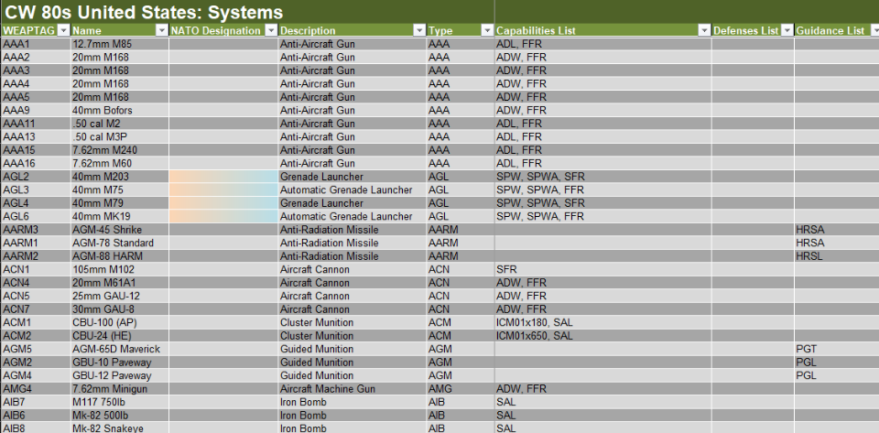

### Capabilities List

These Shared Characteristic Codes for Weapons-Capabilities can be found in Section 5.2 above. If your weapon or system has any of the Capabilities found in the lists, you add them to a comma delimited list in the Capabilities List spreadsheet field.

### Defenses List

These Shared Characteristic Codes for Weapons-Defenses can be found in Section 5.2 above. If your weapon or system has any of the Defenses found in the lists, you add them to a comma delimited list in the Defenses List spreadsheet field.

### Guidance List

These Shared Characteristic Codes for Weapons-Guidance can be found in Section 5.2 above. If your weapon or system has any of the Guidance systems found in the lists, you add them to a comma delimited list in the Guidance List spreadsheet field. You may have more than one guidance system on the weapon.

## Sound Effect

Each weapon has an associated sound effect when it is fired/used. These “*.WAV” files are based on weapon type as noted in the table below. You can add in your own weapon sound effects and that information is covered in the Game Engine Modification document.



# Weapon Munition Types

A munition is defined as a single type of round or burst from a gun tube-based weapon such as a tank gun or mortar tube. Items like ATGMs and most small arms are well enough covered in the standard Systems (Weapons) tab in the data spreadsheets.

This new tab of information requires adding weapon data from the systems tab to the new munitions tab. Then breaking that information up into unique rounds of ammo based on the various penetration values and Characteristics seen in that weapon system data.

From there, the unit’s weapon list needs updated to show the rounds used and the total number of rounds (or bursts) carried on the platform. The weapons list can be a mix of weapon systems that have munitions or not. See Section 18.24 above for details on how to annotate munition load outs for weapon systems.

**NOTE:** Mistakes in the formatting of the Weapon System and it ammo loadout or munition information can cause the game to crash or have unwanted effects on combat.

## The Munition Types Tab

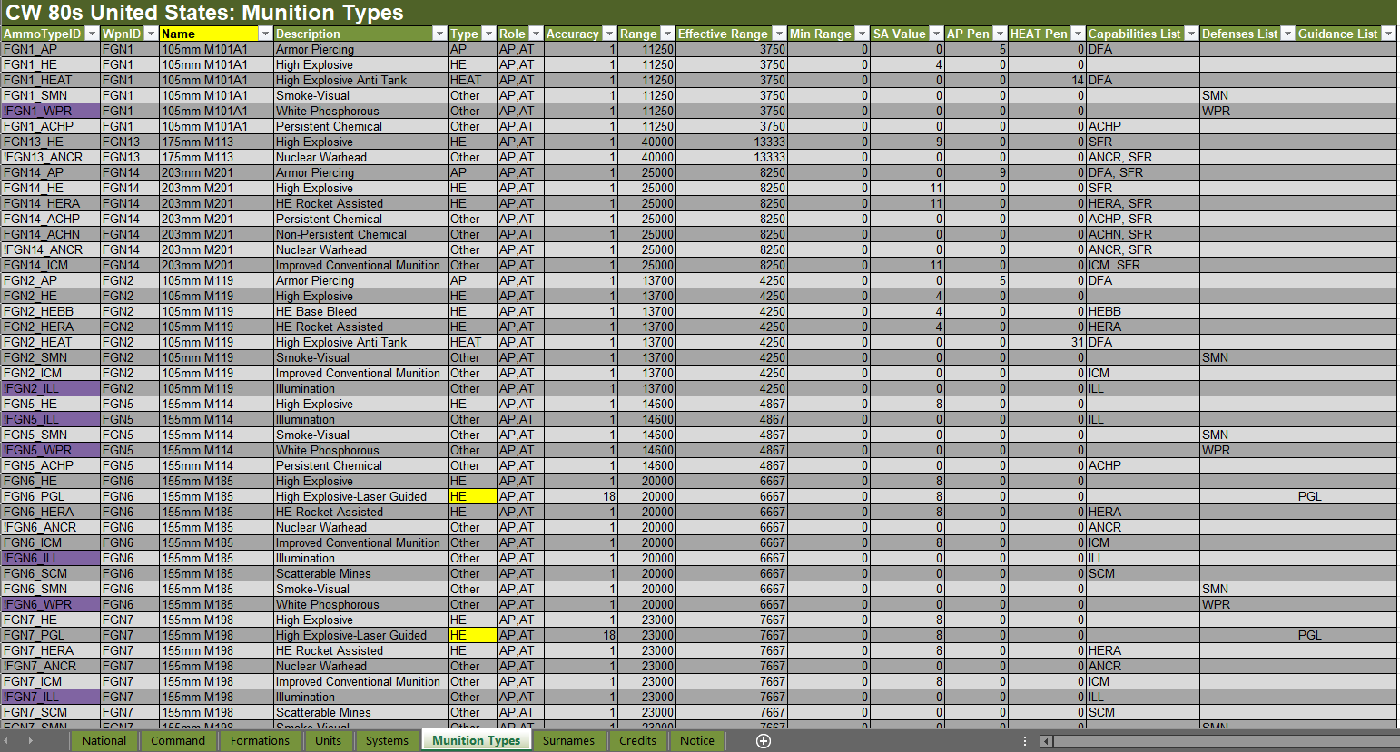

The Munition Types Tab is similar to and uses the values, calculations, and shared characteristic of the Systems (Weapons) tab and the information from Section 10 Systems applies to this table for the columns outlined in Red above and zoomed in below in Section 11.2. The columns outlined in the blue box are new entries that have definitions seen below in Section 11.3.

## Columns Based on Systems Values



The major difference for these columns compared to the Systems tab is the values apply to only one type of munition type like AP or HEAT round.

With this new tab, users can craft any number of rounds used by a weapon system that has “projectile” munitions.

For example, you could create data for three 120mm AP rounds. Each can have different values for ranges, penetration, or Characteristics.

If a munition type does not use one or any of the values for SA Value, AP Pen, or HEAT Pen, place a zero (0) in the field.

Be sure to only apply those Characteristics that apply to the type of round/munition being designed. This is different from the Systems tab where the older data covers all munition cases and is parsed out internally in the code for capability.

## Columns for the Munition Types

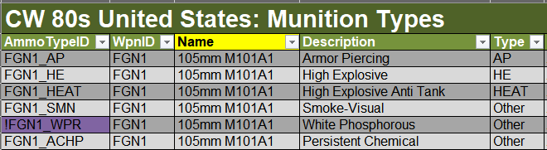

These new columns have the following definitions.

### AmmoTypeID

The AmmoTypeID must be a unique name that must start with the Weapon ID (WpnID) of the Weapon from the Systems Tab. In the information above, the weapon ID is FGN1 that is a 105mm M101A1 field gun. After the WpnID add an underscore and then add any alpha numeric name or code. This could be “AP”, “AP1”, “XM896”, “bob42”, etc.

Adding a “!” in front of the AmmoTypeID will cause this munition to NOT be loaded in the game. This is helpful for munitions with non-implemented code or effect.

### WpnID

This must be the unique WEAPTAG value of the particular weapon as seen in the Systems Tab.

In the image above, the WpnID is “FGN1” from the Systems tag.

### Name

This is the name of the munition type. This can be any alpha-numeric identifier. Try to keep the name to 24 characters to be visible in the Ammo dialogs in game.

In the image above we just used the name of the Weapon System. A better name may have been “105mm AP Round” for the first entry.

### Description

This describes the basic Type of Munition and is used in the Ammo dialogs found in game. This should be a basic description of the function of the round.

In the image above the first munition type is an “Armor Piercing” round.

### Type

These codes tell the code how to apply the round when fired. Codes in Italic are provisional and may be added later.

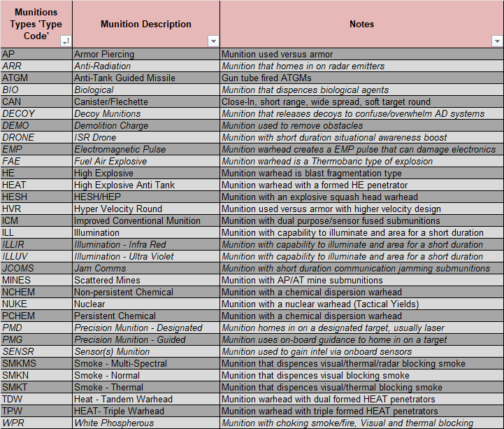

These codes must be typed in as shown to function in the game.

**NOTE:** New custom types will not function in game and require coding to work. Contact the developers if new items are required.

## Setting Up Munition Types

The following image shows how to add defined Munition types in the Units Tab in the Integrated Weapons List with other weapons.

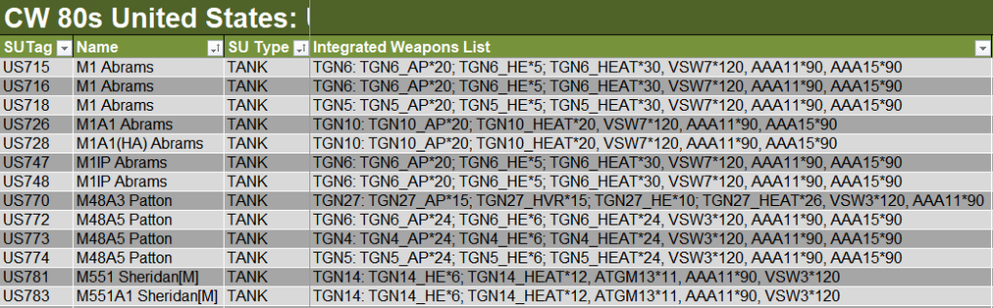

### Munition Type Entry

Any number of weapon systems can be added to a unit, and they can be a mix of regular weapons from the systems tab or Munition Type weapons that are further defined by round type in the Munition Types Tab.

Here are the rules to follow to format a valid Integrated Weapons List:

* Each Weapon System or Full Munitions entry MUST be separated by a comma and single space.
* Weapon Systems are denoted by a WEAPTAG, then “*”, and then the number of rounds/bursts for the weapon. In the data excerpt above, these Weapon Systems are entries like “VSW7*120”, “ATGM*13”, or “AAA11*90”.
* A Munitions based Weapon entry has the following format.
  + Starts with just the WEAPTAG value and then a “: ”.
  + Then any number of defined munition types by AmmoTypeID then ”*” and then the number of rounds
  + Each Munition Type MUST be separated by a ”; ”.
  + The last or only Munition Type must be followed by a comma if another weapon entry follows.

# Surnames

For each nation there is a Surname tab, which has a list of 200 common surnames, which the game will use for naming various leaders at random. The Surname table is four columns, with 50 entries in each column. These are text entries, and special characters in names may be used.

# Credits

The Credits tab allows the user to note who worked on the file and allows for any revision tracking. This tab is optional and not read by the program.

# Notice

The Notice tab states the specific game engine and data file name, as well as noting the “On Target Simulations LTD” copyright. This tab is optional and not read by the program.

# Data Folder Setup

The location of the National Data Files and supporting files is found in [Game Setup Location]\Modules\Common\Data\[Your Country File Name*]. Within this Country Named location you need to have the following sub-folders for supporting materials: Backgrounds, Badges, Dialogs, Unit Images. See the image below.

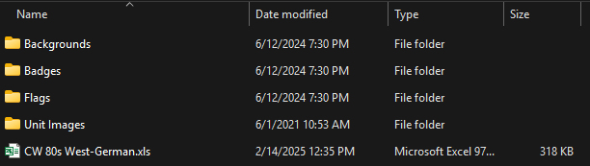

As seen above, you may have any number of Excel files (*.xls) in a National folder if their names are different.

* = Within each file on the National Tab, the Nationality entry under Game Defaults **MUST** match the “Your Country File Name” for the game to find and sort data files in the scenario editor.

# Using the Data Validation Tool

Included in the Data Folder is an Excel Macro enabled file (*.xlsm) called Data Validation Tool. This spreadsheet has a VBA code form that can be used to review each tab of a National Data Spreadsheet and tell you about any detected errors. While it is not 100% foolproof, the tool does find 95% of the typical errors that can take time to find without the tool.

We are still in the process of improving the tool as well and any feedback or suggestions for other typical editing faults to cover is appreciated.

The spreadsheet itself also contains instructions like the ones shown here for easy reference when using the tool. The spreadsheet code and supporting internal tables are hidden and locked at this time to avoid any possible support issues.

**WARNING:** The current Data Validation Tool is not updated to handle the new Tactical Transport data files and if run on a TT based files it will damage the Units tab of the spreadsheet and other areas. **We are working on a revised tool and hope to have that ready later this year. Sorry for any editing issues this may cause in the interim. Please follow the steps below to build a Data Check File for your data.**

## Make a Data Check File

As noted in the Warning above, the current version of the Data Validation program will damage a standard data file if processed and lead to game crashes. Fortunately, we have a work-around that we use to validate all the game’s data files. That process is as shown below.

### Steps to Follow

1. Select the data file from the Nation that you want to verify any changes or additions (or if it is a new file). In this example from the Belgian Nation Data Folder.

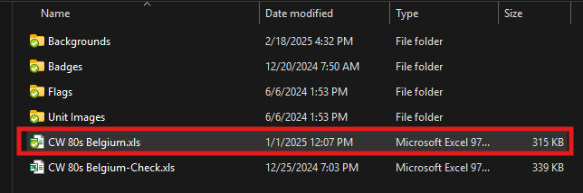

1. Make a copy of the file and name the file as [Filename]-Check.xls. this will be an exact copy of the existing data file.

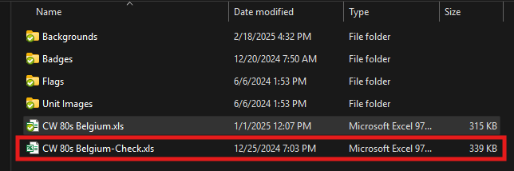

1. Open the Check file and click on the Units Tab.

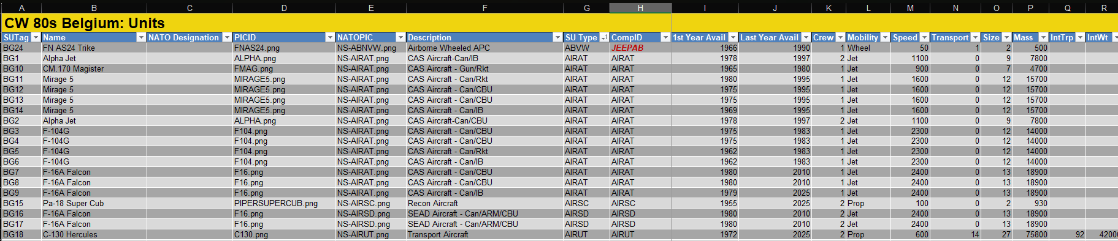

1. Scroll the data until you can see columns P (Mass) through T (ExtWt) on the screen.

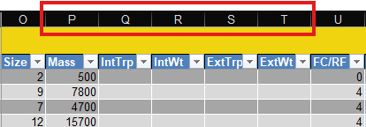

1. Select columns P though T.

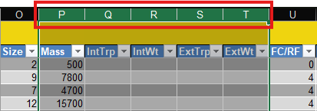

1. Use the spreadsheet program’s tools to delete the selected columns.
2. After deleting the unneeded columns, your sheet should like the image below with column O (Size) now next to column P (FC/RF)

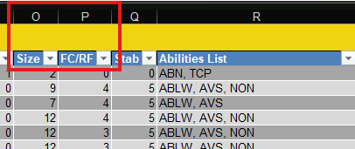

1. Click on the National tab and save.
2. You are now ready to Validate the new Check File!

## How to use this Tool

1. If the Data Validation Tool dialog is not showing, click the Run Tool button.

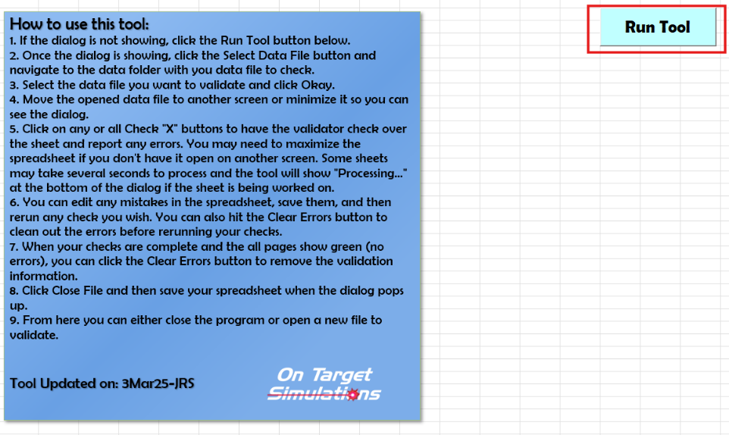

1. Once the dialog is shown (image below), click the Select Data File button and navigate to the data folder with your data file to validate. The top text box will show the drive location of the games data folder based on its installed location on your system.

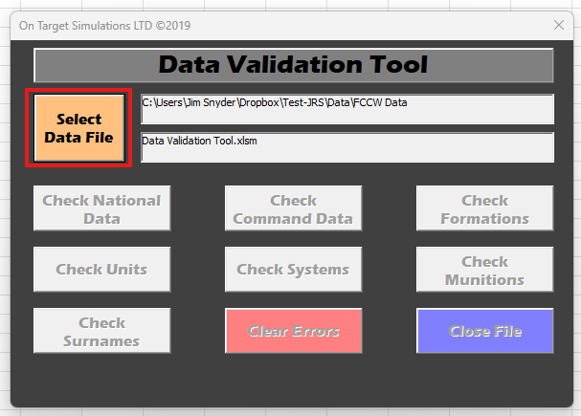

1. Select the [Filename]-Check data file you want to validate and click Okay.

**WARNING: DO NOT** use the regular game data file or you can crash your game when the validation breaks the file**.**

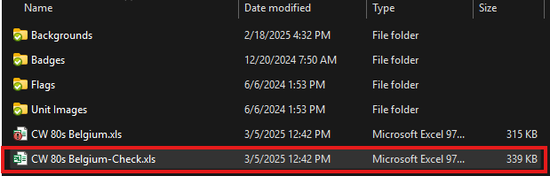

1. Move the opened data file spreadsheet to another screen or minimize it so you can see the dialog.
2. Click on any button to have the validator check over the stated tabs on the data sheet and report any errors.
   1. You may need to maximize the spreadsheet if you do not have it open on another screen.
   2. Some sheets may take several seconds to process, and the tool will not "Processing..." at the bottom left if the sheet is being worked on. In particular, the Formations and Units tab can take time to process if there are many entries or you have an older processor.

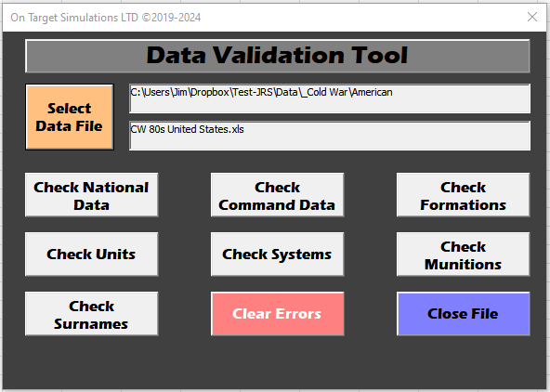

1. You can edit any mistakes in the spreadsheet and save them and then rerun the check without reloading the file.
   1. Any field with an error in it will turn pink and there will be a red colored Errors column off to the right of the information in the spreadsheet tab.
   2. The specific type of error, what information is bad, and the cell ID are shown if known. There are some cases where the error will be detected, but the cause may not be relayed in the error message. In those cases, there is usually a missing comma, wrong symbol in a formation or weapon system entry, or a typo in a name or ID tag value.
   3. If there are no errors on the sheet the background for the Error cell will be green. The only exception to this is the current Munitions tab. There are several entries that are not fully active in the game, and they will show as an error, but will not affect the game. The are munition entries starting with the “!” symbol.

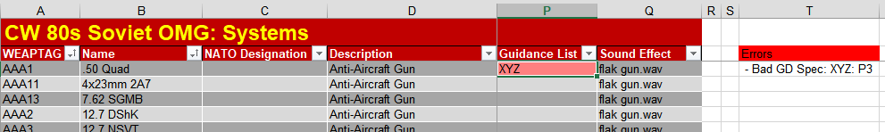

1. When your checks are complete, and all pages show green for errors you can click the Clear Errors button to remove the validation information.

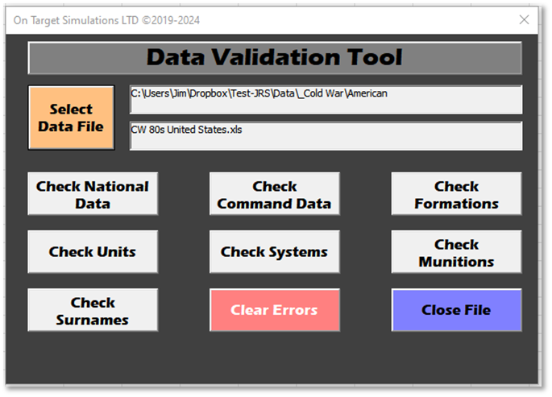

1. Click Close File and then save your Check spreadsheet when the dialog pops up.
2. From here you can either close the program or open a new Check file to validate and repeat the process.

## Updating the Main Data File

Now that you have a validated Check file and the original National data file in the folder, we need to update the Check file into a new National file and archive the older National file in case we need it in the future. Here are the steps to perform this action.

1. Rename the existing National file to old-[Filename].xls in file explorer. For example, old-CW 80s Belgium.xls.
2. Open both old-[Filename].xls and the [Filename]-Check.xls files.
3. In your Check data file, go to the Units tab, select column P and add in five new columns as shown below.

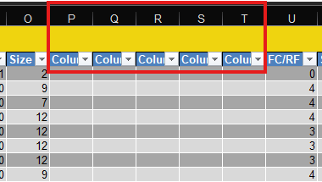

1. Go to the old-[Filename].xls file and go to the Units tab. Select cell range P2 through T? (the last table entry in column T) as seen below and then select copy.

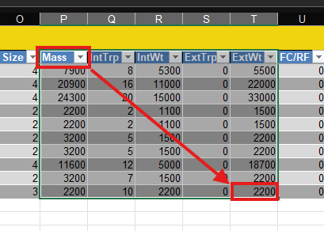

1. Return to [Filename]-Check.xls and select cell P2 as seen below and then select paste.

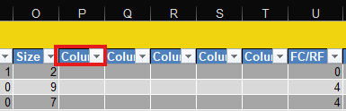

1. Review the Units data sheet to make sure that all the data has pasted to the correct cells and fills all the entries to the bottom of the table as seen in the image below.

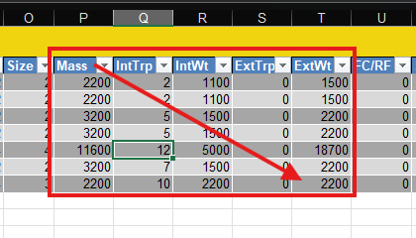

1. Save the file.
2. Go into file explorer and change the [Filename]-Check.xls file to read [Filename].xls.
3. The folder should now have the game required [Filename].xls and a backup called old-[Filename].xls.

If you need to process new edits to the National data file, you can make a new Check file as outlined above and delete or archive the old-[Filenam].xls file as you repeat the process.

## Additional Tool Features

This section will cover features of the Data Validation Tool and any new features or capabilities.

### Worksheet Header Check

The Validation Program checks all the names used as headers for each of the main datasheet tabs in the workbook. If any are incorrect, they are automatically replaced, and the repair is noted in the lower right of the Tools dialog box. If all is correct the lower right notification notes the sheet’s headers have been checked.

### Data Elements Check

The Data Validation Tool is updated to include checks for the newly added/removed characteristics and any other new data types referenced in the data sheets.

### Formation Tab Checks

The tool checks for the valid range of Indented Nodes via the “<1” through “<8” codes in the Formation Code Data Field.

### Units Tab Checks

The Data Validation Tool checks both the Common and NATO folders in the Data folder for matching image callouts from the Units tab for the counter silhouette filenames used in the data files. This is the PICID and NATOPIC entries in the Units data tab.

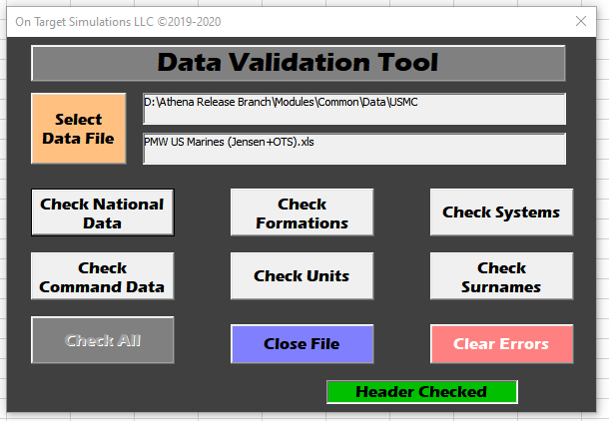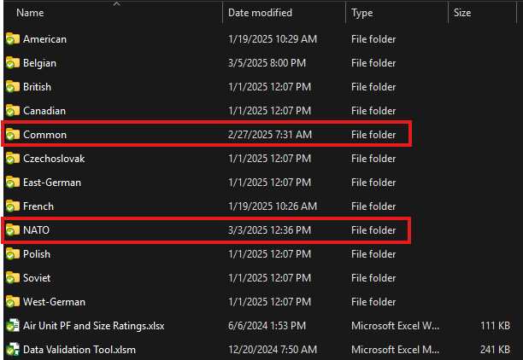

### Unused Units Check

The Data Validation Tool also performs a check to see if there are any Units not called out in the Formations tab. This is based on scanning the COMPIDs used and those in the Units tab. A red error field will pop up on the right side of the table and note any missing units.

# File XLS Import/Export Editing

Being able to both export certain key scenario data, edit it via an Excel file and then import changes back into a scenario file is a powerful tool for advanced users. Like anything data editing related, you can also break the scenario with a bad data element input.

**WARNING:** Right now, there is no tool like the Data File Validation Tool to sweep for bugs and typos. We strongly advise that you make well understood small changes. Also, it is a particularly good idea to have your scenario backed up in case something breaks.

## Exporting Scenario Data

First, we must enter the Scenario Editor from the Main Menu screen. Click on the “Scenario” button in the Edit section.

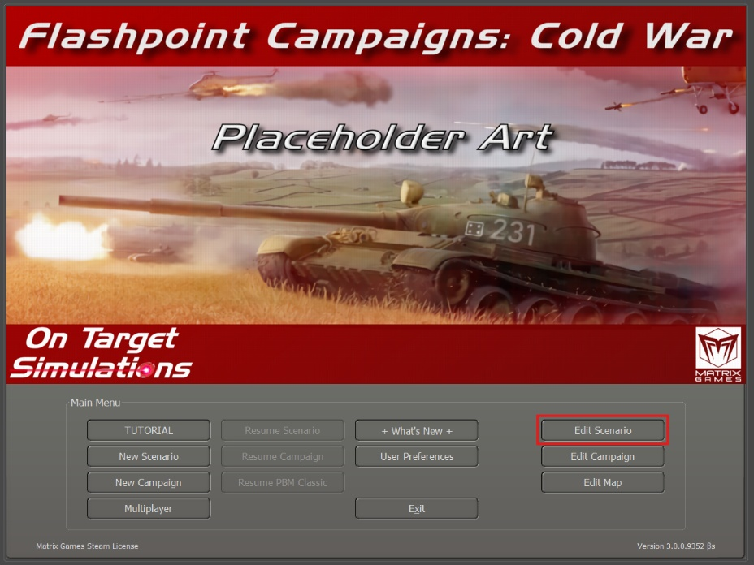

Next, we need to load a scenario that we want to make a change in. Click on the “Load Standalone SCN File” button.

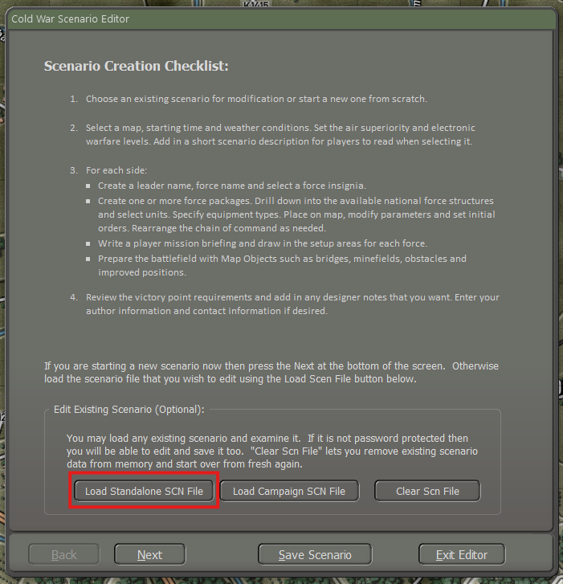

For this example, I am going to edit a scenario called “Brothers in Arms”. As the information notes, it is a small scenario featuring Cold War American, West-German and East-German units. Click “Load” to load the scenario.

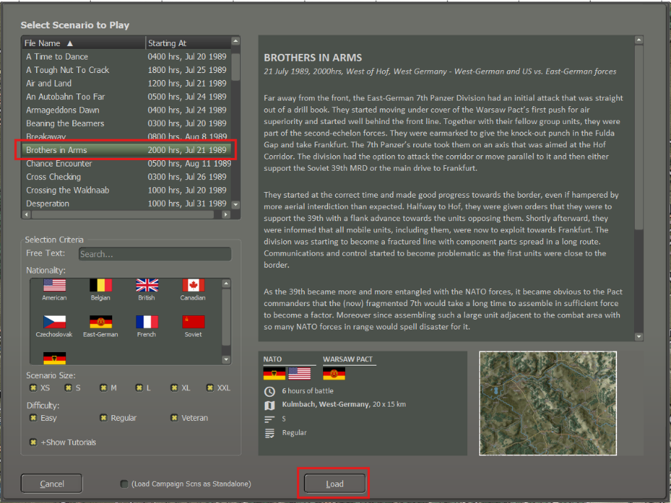

Here is the scenario after loading.

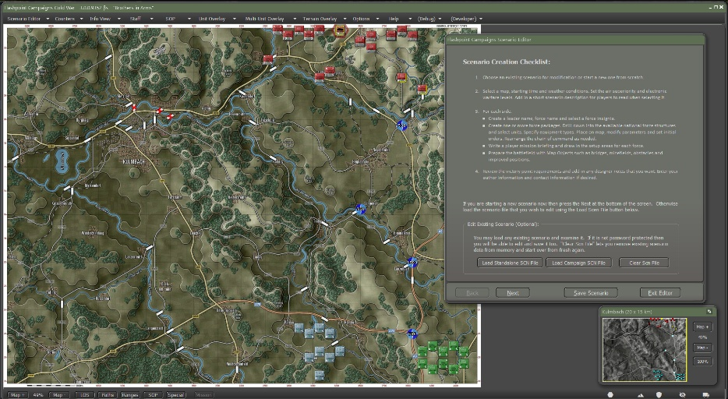

Now, go to the Top Menu and click on “Scenario Editor” and then click on “Export Game Data to XLSX file”.

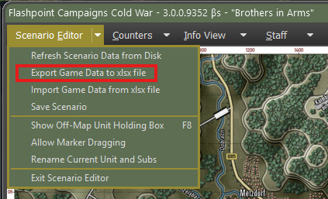

An Announcements dialog will pop up with some important information about using the XLS Export/Import tool. Worth a quick review.

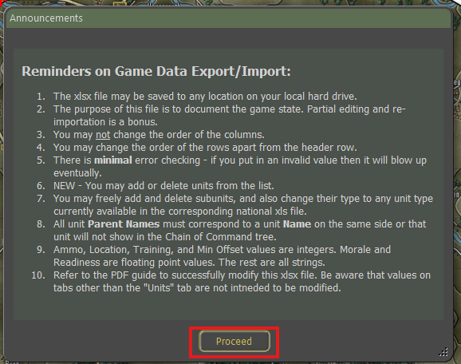

Hit “Proceed” and you are presented with the Save File screen for the exported XLSX file. By default, the game uses the scenario name. You can use that or change it to something else. It may be a good idea to export the file twice and name one with “_Original” or something similar in case you wish to revert changes back to the original scenario information.

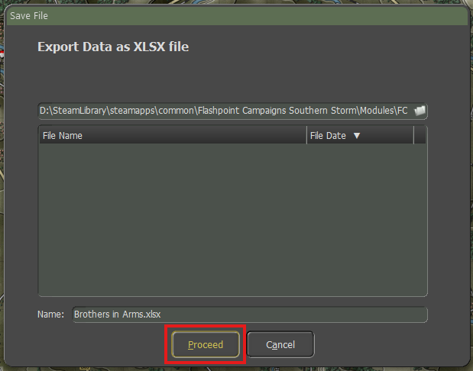

Click “Proceed” to save your export file. If all goes well with the export, you will see the following dial box. Hit “OK”. If you are exporting to the same file after the first time, you will get a confirmation dialog to overwrite the existing file.

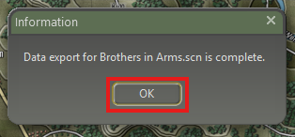

The exported XLSX file is now located in the Scenarios sub-folder of the FCCW module. In this example, we are using a scenario for Cold War and the “Brothers in Arms.xlsx” file is in the [installed location]/Modules/FCCW/Scenarios or if a Steam install it is located in [Steam Drive]\ D:\SteamLibrary\steamapps\common\Flashpoint Campaigns Cold War\Modules\FCCW\Scenarios as seen below.

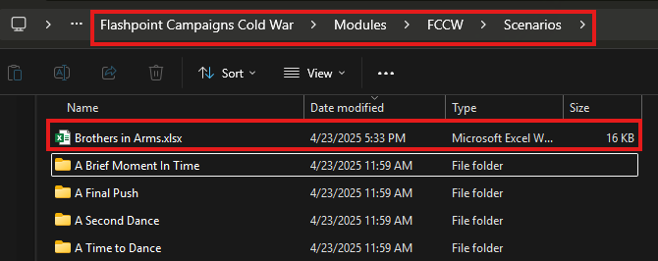

Next is the discussion on editing the file in Excel (or comparable program).

## Editing Scenario Data

First, we need to open the exported scenario data as noted above with Excel or compatible program. Once opened in Excel, there are four tabs of various data in the exported file.

**NOTE:** Currently, the only data that can be edited and imported back into a scenario is in the Units tab. In the future we will be working to make all four tabs full import/export capable.

You can browse the other tabs if you wish. For now, let’s concentrate on the Units tab and click it to look at what parameters are available to edit.

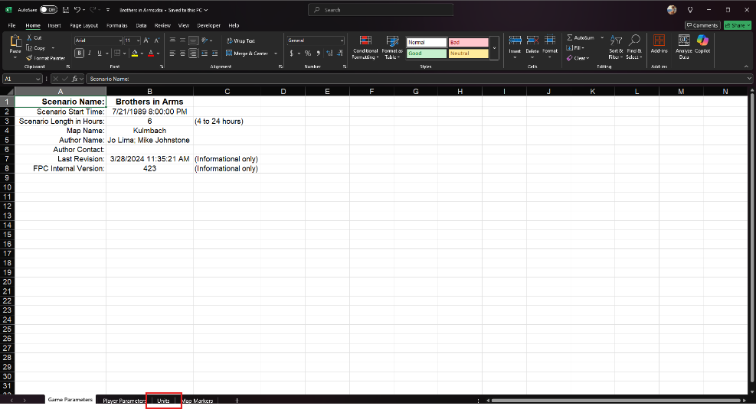

Click the Unit tab and you should see the following columns of data. A bit of an eye chart but we will go over each one next as to what you can and can’t do.

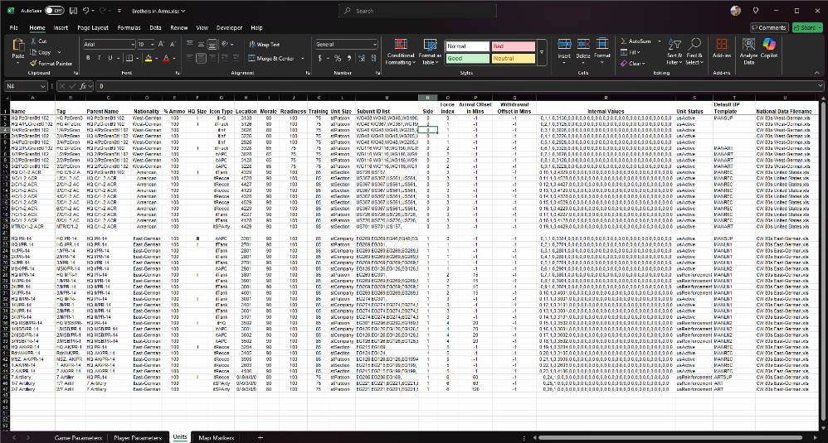

1. Name: This is the name of the unit seen on the counter and in any of the dialogs where a unit name is shown. This can be edited freely.
2. Tag: This is the generated Tag ID from the Formation creation, and it is generally the same as the Name field. Edit to match the Name field if changed.
3. Parent Name: This field tells which unit a sub-unit is subordinate too. To match up to an HQ unit this field needs to be the same as the Tag field of the commanding HQ.
4. Nationality: This is the data folder name of the National Data Filename found in column “U”. If you are adding new units from a new National folder the name in column “D” and the XLS Filename in “U” must be named exactly as they are in the folder and file or the game will crash when it can’t find the data. You can mix units from any number of nations in this manner. The subunits in column “M” must ALL come from the same national data file.
5. % Ammo: You can set the percentage of ammo units in the scenario here. 0 to 125% are valid integer values to use.
6. HQ Size: This is the same HQ size value found in the data editing information of Data Files. This represents the command level of the HQ, not the actual size of the HQ.

**NOTE:** the “...” symbol for a platoon is 3 periods and **NOT** the ellipse symbol. Excel will auto correct this if you do not change it in the Options/Proofing/Autocorrect Settings. Find the Ellipse correction, highlight it and then delete it.

1. Icon Type: This is an internal value, and it should not be changed. If you are adding new units, you will want to add this in and try to match existing values seen in the scenario. For example, if you add and new Tank Company, you will want to use the “itTank” reference.
   1. Valid Icon Types are the following: itRecce, itHelo, itTank, itMechInf, itInf, itSPAT, itAntiTank, itHQ, itEngineer, itFlak, itSPArty, itArty, itTruck, itAir, itWMD, itDrone
2. Location: This is a 4-digit map coordinate or a “0” if the unit is off-map followed by /North(-) or South(+) distance in kilometers, /West(-) or East (+) distance in kilometers, and /0/0.

**NOTE:** It is possible to place a unit out of effective range adjusting these numbers and that can lead to a crash. Using the in-game Off-Map Asset Placement dialog is a safer way to make these adjustments in the Scenario Editor.

1. Morale: You can change the Morale value of any unit in this field. Valid integer values are 0 to 100.
2. Readiness: You can change the Readiness value of any unit in this field. Valid integer values are 0 to 100.
3. Training: You can change the Training value of any unit in this field. Valid integer values are 0 to 100.
4. Unit Size: This is the actual size of the unit based on the number of subunits.
   1. Valid Unit Sizes are the following: stArmy, stCorps, stDivision, stBrigade, stRegiment, stBattalion, stCompany, stBattery, stSquadron, stPlatoon, stSection, stSquad
5. Subunit ID List: This is the most edited column in many cases. This lists all the subunits by Tag ID from the National Data File referenced in Column “U”. You can add or remove any number of units in this field if they are from the noted data file. The last unit MUST have a trailing comma.
6. Side: Units are either Side 0 (Blue) or Side 1 (Red). No other sides are currently supported.
7. Force Index: Be careful editing this field. It matches up to the Force package in the scenario editor at an N+1 value. For example, a force index of 0 will be the Force 1 listing in the scenario editor. If you add units to an existing Force, they will inherit the Battleplanes of that force (if they have any). New Forces if created have no Battle Plans until they are created in the Scenario Editor.
8. Arrival Offset in Mins (Minutes): A “-1” indicates that the unit starts on the map or off-map at the start of the scenario. Any integer time in minutes within the play time of the scenario can be used to set the arrival time of a reinforcement.
9. Withdrawal Offset in Mins (Minutes): A “-1” indicates that the unit stays on the map or off-map for the duration of the scenario. Any integer time in minutes within the play time of the scenario can be used to set the withdrawal time “X” minutes into the scenario.
10. Internal Values: **DO NOT** edit or attempt to add for new units. The game will import any new units and not look for this field. We may try to move this to its own tab in the future.

**WARNING:** changing ANY values in this field or adding or removing values will cause the game to crash if this file is imported with adjusted values.

1. Unit Status: This is the game state of the unit. “usActive” is the default state of any unit that is in the scenario. You can also set to “usInactive”. This unit will not act until fired on or until it spots an enemy unit. Units set to come on as reinforcements will have a “usReinforcement” code in this field.
2. Default BP Template: This is from the Formation’s tab of the National Data file.
3. National Data Filename: As noted earlier, this is the XLS filename of the datafile related to the Subunit IDs seen in Column “M”. The file must also reside in the Nationality Folder noted in Column “D”. This relationship is critical for proper data values to be read in during the import of the modified XLSX file.

## Best Use Cases for the Tool

The following list provides several uses for this Import/Export tool for the game.

* You can easily rename units and display the Tags seen in the scenario.
* You can resubordinate units to new HQs by changing the Parent Name to another different Parent Name.
* You can quickly adjust the starting ammo levels for all the units in the scenario.
* You can quickly adjust the Morale, Readiness, and Training levels of all the units in the scenario.
* You can add or remove subunits from the units in the scenario.
* You can swap subunits in a unit. This is useful to change a unit’s subunits from one type of platform to another. For example, change M1A1s to M-60s.
* You can remove unwanted units from the scenario by deleting the row.
* If you are very careful, you can add new units to the scenario. Great care must be used to properly add values for the Internal values. It is a good idea to copy an existing similar cell and then change the second value to be one greater than the highest value for a side and match the location value with the fifth value in the string.
* You can change or add units from another nation by changing the Nationality and National Data Filename and then adding the correct units in the subunit list and also making the Name, Tag, and Parent Tag correct.

After you have done all the edits on the Exported Data File, save, and close it. In the next section we will go over the Import Data File steps.

## Importing Scenario Data

After saving the edited date file, the next step is to import the modified data back into the scenario.

Click on the “Scenario Editor” menu item and then select “Import Scenario from XLSX” item.

**WARNING:** It is important to load up the correct scenario for the datafile that you are trying to import. The import will replace the unit’s data with a different scenario/map combination. The best way to avoid an issue is to leave the scenario up while the editing to the Excel file is being done. That also helps see units, locations, and other items helpful to the editors.

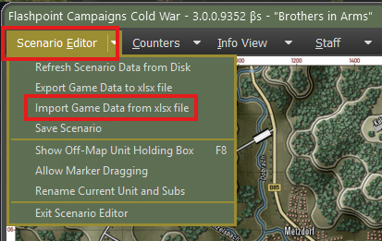

The following dialog box will pop up warning about loading the wrong file into your scenario. Click proceed to get to the Import Data from XLXS file dialog.

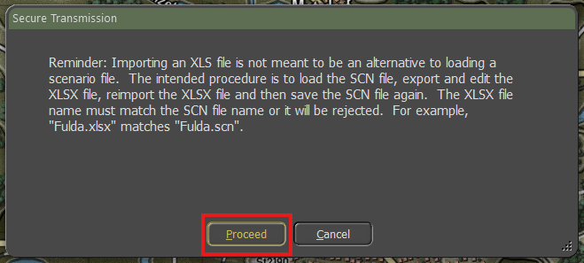

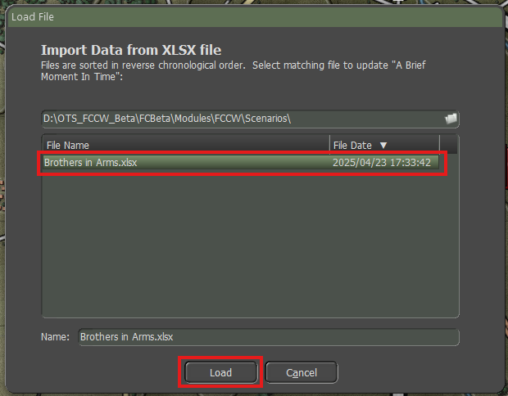

Select the correct XLSX data file to import in the list, in this case “Brothers in Arms.xlsx” and then hit “Load” to have the data imported into the scenario. Currently there are no indicators that things are done. Give the process a few seconds and then look for your modifications.

Save your scenario by clicking the Save Scenario button in the Scenario Editor dialog if all the changes appear to be made and are as intended.

**NOTE:** If you made alterations to an existing scenario, we strongly suggest changing or altering the scenario name to note the new file so it can be understood when loading all scenarios for game selection.

## Limitations/Uses of this Tool

As noted in the previous sections, there are several possible pitfalls doing this export/import shuffle, but this tool does give the user the ability to make several scenario changes on the fly without having to rebuild a scenario from scratch or even using saved packages. If the simulation is being used as a training tool, the ability to make rapid changes to adjust force balance and soft factors is a time saver.

# Future Updates

As we continue working on the game engine and adding more features, we will update our documentation and include the latest versions with new builds.

# Flashpoint Campaigns Credits

## On Target Simulations

* Lead Programmer and Head Honcho: **Robert "Ironman" Crandall**
* Data, Programming, Graphics, and Sound: **Jim "Cap’n Darwin” Snyder**
* Programming, Data, Models, and Research: **Jeff “Iron Mike” Sugden**
* Map Master, Programmer, AI, and Graphics: **William van der Sterren**
* Quality Czar and Testing Lead: **Charles “The Whip” Belva**
* Programming: **Kevin “SgtZDog” Zemon, Will Jackson, Alex Kriesel**
* Testing: **Tomasz Niedzinski**

## On Target Simulations Content Team

* Alexander “Stimpak” Schwarz, David “22sec” Whitt, Mike “MikeJ19” Johnstone, Joao Lima, Jurrie van der Zwaan, John “JohnO” Osborne, Jorgen “Jotte” Torgersson, Jo van der Pluym, Scott “WABAC” Gibbs and Steve “Mad Russian” Overton

## Cold War Beta Testers

* Names to be added before release

## Matrix Production Support

* **Erik Rutins, Maxim Klose-Ivanov**

# OTS on the Web

Matrix Games Forum: <https://www.matrixgames.com/forums/viewforum.php?f=10149>

Check Us Out on Discord: <https://discord.com/channels/911711314051739659/911711314257248331>

Check Us Out on Steam: *“Pending a page URL*”

**© 2025 On Target Simulations (OTS), LTD. All Rights Reserved. The images used and OTS Logo are property of On Target Simulations, LTD. All other marks and trademarks are the property of their respective owners.**